CampusNexus

Build a Transcript Request Process Using FB WF

Campus Management Corp.

Web Site

[www.campusmanagement.com](http://www.campusmanagement.com/)

Contact Information

Phone: 1.561.923.2500

Sales/Support: 1.561.999.9904

Toll Free: 1.800.483.9106

Facsimile: 1.561.999.0096

Address

Campus Management Corp.

5201 Congress Ave

Boca Raton, FL 33487 USA

Copyright

© 2019 Campus Management Corp. All rights reserved. Campus Management Corp. and the Campus Management logo are trademarks or service marks of Campus Management Corp. These marks may be registered in the U.S. or other countries. All other registered trademarks and service marks are the properties of their respective owners.

Contents

Resources 4

Angular JS 4

Understanding OData 6

Validation Regex property in Forms Builder 6

Log File Location & Names 6

Agenda 7

Introduction 8

Course Objectives 8

Target Audience 8

Course Prerequisites 8

Lesson 1: Create a Student Self-Service Form and Supporting Workflow 9

Exercise: Create a Transcript Request Form Sequence and Supporting Workflow 9

Lesson 2: Validate the Transcript Request Process 75

Exercise: Validate the Transcript Request Process 75

# Resources

[www.mycampusinsight.com](http://www.mycampusinsight.com)

**Note**: If you do not have a MyCampusInsight login, contact your Customer Enablement Manager.

<https://github.com/campusmanagement>

[http://community.campusmgmt.com](http://www.odata.org/getting-started/understand-odata-in-6-steps/)

## Angular JS

https://docs.angularjs.org/guide/introduction:

AngularJS is a structural framework for dynamic web apps. It lets you use HTML as your template language and lets you extend HTML's syntax to express your application's components clearly and succinctly. AngularJS's data binding and dependency injection eliminate much of the code you would otherwise have to write. In addition, it all happens within the browser, making it an ideal partner with any server technology.

AngularJS is what HTML would have been, had it been designed for applications. HTML is a great declarative language for static documents. It does not contain much in the way of creating applications, and as a result, building web applications is an exercise in what do I have to do to trick the browser into doing what I want?

The impedance mismatch between dynamic applications and static documents is often solved with:

* **a library** - a collection of functions, which are useful when writing web apps. Your code is in charge and it calls into the library when it sees fit. E.g., jQuery.
* **frameworks** - a particular implementation of a web application, where your code fills in the details. The framework is in charge and it calls into your code when it needs something app specific. E.g., durandal, ember, etc.

AngularJS takes another approach. It attempts to minimize the impedance mismatch between document centric HTML and what an application needs by creating new HTML constructs. AngularJS teaches the browser new syntax through a construct we call directives. Examples include:

* Data binding, as in {{}}.
* DOM control structures for repeating, showing and hiding DOM fragments.
* Support for forms and form validation.
* Attaching new behavior to DOM elements, such as DOM event handling.
* Grouping of HTML into reusable components.

**Angular JS Resources**

[https://www.w3schools.com/js/js_comparisons.asp](http://RegExLib.com)

[https://teropa.info/images/angular_expressions_cheatsheet.pdf](https://www.w3schools.com/js/js_comparisons.asp)

[https://docs.angularjs.org/guide/expression](https://teropa.info/images/angular_expressions_cheatsheet.pdf)

## Understanding OData

http://www.odata.org/getting-started/understand-odata-in-6-steps/

OData (Open Data Protocol) is a standard that defines the best practice for building and consuming RESTful APIs. OData helps you focus on your business logic while building RESTful APIs without having to worry about the approaches to define request and response headers, status codes, HTTP methods, URL conventions, media types, payload formats and query options etc. OData also guides you about tracking changes, defining functions/actions for reusable procedures and sending asynchronous/batch requests, etc. Additionally, OData provides facility for extension to fulfill any custom needs of your RESTful APIs.

OData RESTful APIs are easy to consume. The OData metadata, a machine-readable description of the data model of the APIs, enables the creation of powerful generic client proxies and tools. Some of them can help you interact with OData even without knowing anything about the protocol.

To learn more about the OData query syntax, see [http://www.OData.org/](http://community.campusmgmt.com) and look for "Basic Tutorial” and "Advanced Tutorial”.

## Validation Regex property in Forms Builder

***Validation Regex*** is the regular expression pattern to validate the input. Use site like [http://RegExLib.com](https://docs.angularjs.org/guide/introduction) to search and test ***Regex*** patterns, or construct your own with ***Regex*** tools like [Expresso](https://www.codeproject.com/Articles/3669/Expresso-A-Tool-for-Building-and-Testing-Regular-E). If the user input does not produce a Regex match, the "***Validation message***" will be displayed.

***Examples***:

***Regex*** that enforces a minimum of 11 digits for a phone number where the first digit must be "1": 1\d{10}

***Regex*** that enforces a phone number in the format (###)###-####: ^\([0-9]{3}\)[0-9]{3}\-[0-9]{4}$

***Regex***that matches a hyphen-separated social security number: ^\d{3}-\d{2}-\d{4}$

## Log File Location & Names

Log files for Forms Builder are located at:

\\[server](https://docs.angularjs.org/guide/expression)[\c$\logs](http://www.odata.org/) - (where server is the hostname for your environment)  
Look for FormsBuilderRenderer-*date*.txt & FormsBuilderDesigner-*date*.txt

# Agenda

|  |  |  |
| --- | --- | --- |
| **Time** | **Topic** | **Activity** |
| 8:30 – 8:45 AM | Course Overview and Introductions |  |
| 8:45 – 9:00 AM | Student Self-Service Transcript Request Process Overview | Demo |
| 9:00 - 10:00 AM | Lesson 1: Create a Student Self-Service Form and Supporting Workflow | Exercise: Create a Transcript Request Form Sequence and Supporting Workflow |
| 10:00 – 10:15 AM | **Break** |  |
| 10:15 - 11:30 AM | Lesson 1: Create a Student Self-Service Form and Supporting Workflow Continued |  |
| 11:30 - 12:00 PM | Lesson 2: Validate the Transcript Request Process | Exercise: Validate the Student-Self Service Form and Supporting Workflow for the Transcript Request Process |

# Introduction

This is an advanced, hands-on session. Participants will learn how to build a student self-service Transcript Request Process using Forms Builder, Workflow, and CampusNexus Student.

## Course Objectives

Upon completion of this session, participants will be able to:

* Build a Transcript Request Form Sequence
* Automate the Transcript Request Process utilizing Workflow and CampusNexus Student configurations
* Manage Students who have submitted Transcript Requests

## Target Audience

Technical Business Analysts, System Administrators, Database Programmer, IT staff members

## Course Prerequisites

Prerequisite Knowledge:

* Understanding of Business Processes
* Understanding of CampusNexus Student Application and Schema and/or CampusNexus CRM Application and Schema
* Aware of .NET Technologies and Understanding of VB.Net
* Create Variables, Assign Data Types, and a Basic Understanding of Development Languages
* Awareness of:
  + Windows Workflow Foundation (4.5)
  + CSS Themes
* SQL Knowledge
  + Ability to create SQL jobs, call Stored procedures and Write Queries
* General Development Knowledge of Variables, Arguments, Control Logic, Exception Handling, Debugging etc.

# Lesson 1: Create a Student Self-Service Form and Supporting Workflow

In this lesson, you will create a Transcript Request Process by leveraging Forms Builder and Workflow.

## Exercise: Create a Transcript Request Form Sequence and Supporting Workflow

1. Navigate to ***Google Chrome*** and Launch ***Designer*** from the ***Bookmarks Bar***.



1. ***Sign in*** using the following credentials:

***administrator***

***testing***

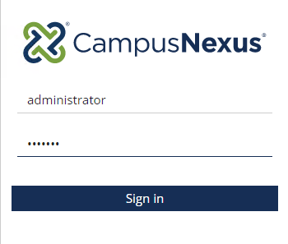

1. Select the ***Form Designer*** to start creating your form.

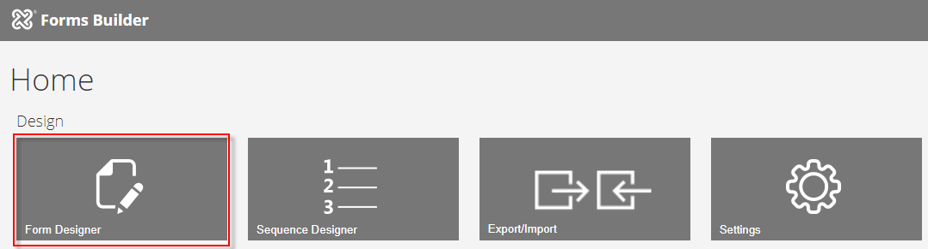

1. Select ***New.*** A ***1 Column*** panel is added to the ***Layout*** pane in the Designer.

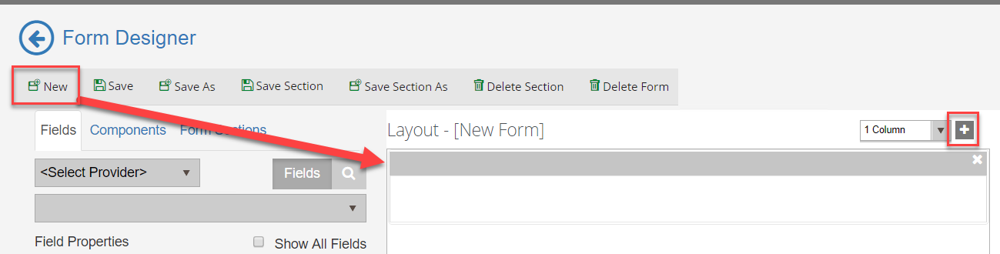

1. From the ***Components*** tab, drag an ***HTML*** component into the panel of the ***Layout*** pane.

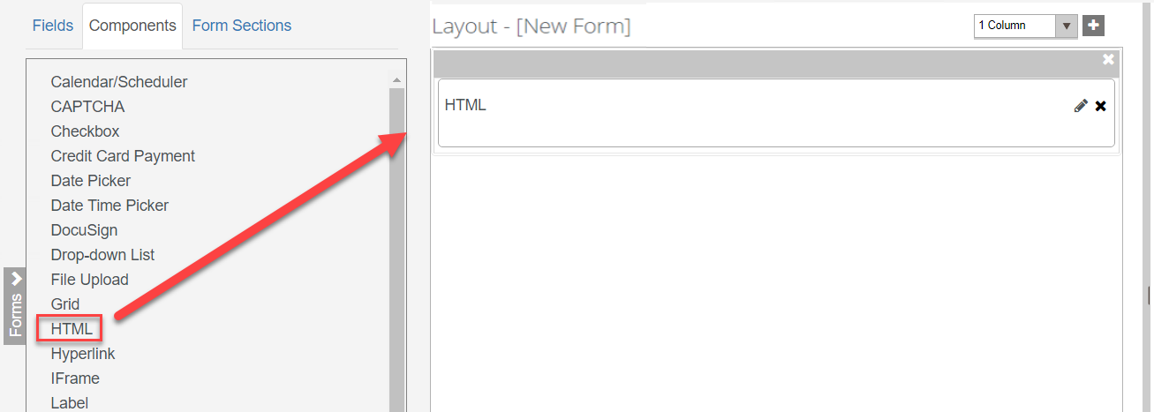

1. Enter the following for the ***HTML*** component in the ***HTML*** property of the ***Control Property Settings*** pane:

***<style> .navbar-default { display: none} </style>Official and unofficial transcripts can be requested through our student website or by mail, fax or phone. To order by phone, call the Office of Admissions and Records Support Center at 1-866-711-1700. Be sure to check your unofficial transcript to make sure your coursework and grades have posted before ordering your official transcript.<p><br>***

***You can request an electronic transcript or pay an additional fee for overnight delivery of a paper transcript if you need expedited service. Please note, some limitations apply to overnight deliveries<p><br>***

***<h4> Please choose from one of the following options:</h4>***

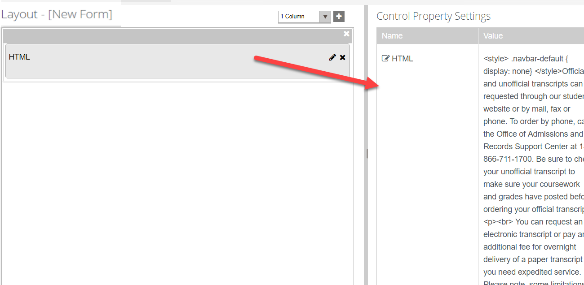

1. From the ***Components*** tab, drag three ***Radio Button*** components into the panel of the ***Layout*** pane.

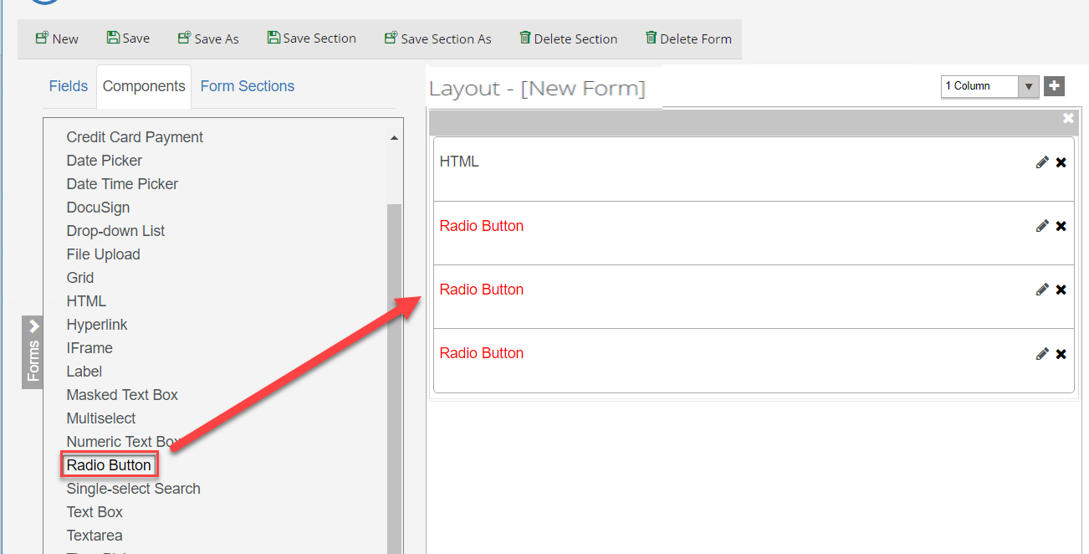

1. Update the properties for each ***Radio Button*** component in the ***Control Property Settings*** pane as shown below:

First ***Radio Button:***

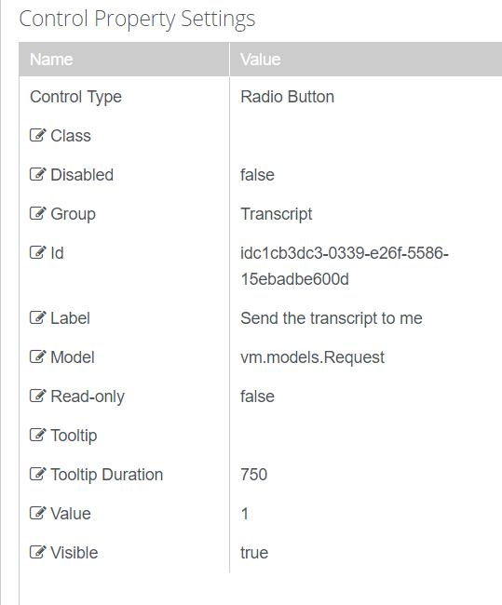

Second ***Radio Button:***

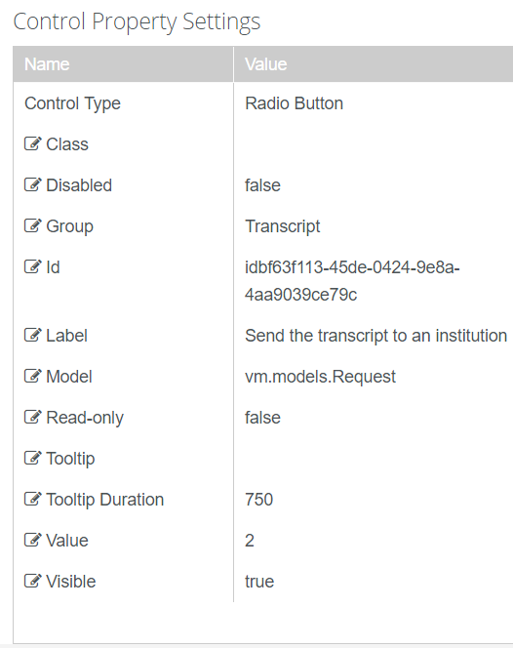

Third ***Radio Button:***

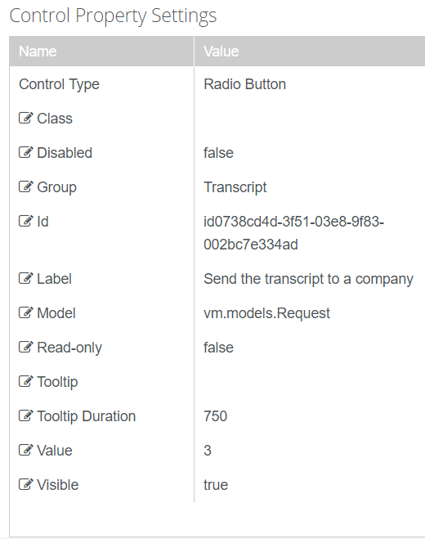

1. ***Save*** and name your Form with your initials at the end as shown below.

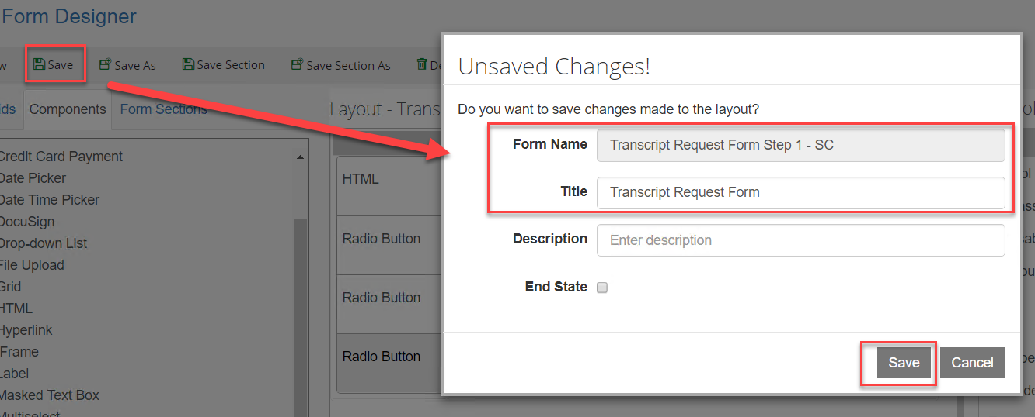

1. Select ***New.*** A ***1 Column*** panel is added to the ***Layout*** pane in the Designer

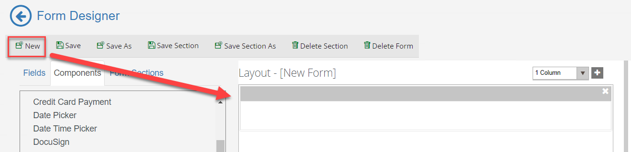

1. From the ***Components*** tab, drag an ***HTML*** component into the panel of the ***Layout*** pane.



1. Enter the following for the ***HTML*** component in the ***HTML*** property of the ***Control Property Settings*** pane:

***Send the transcript to me. Please fill out the information below to order an official transcript. Prior to ordering an official transcript, please verify that all coursework, grades and degrees are reflected on your record by viewing your unofficial transcript as refunds will not be issued. Please note that there is a $7.00 fee per transcript for official transcripts. Additional taxes and fees may apply in some states.<br><p>***

***Official transcripts can be mailed outside of the US only by contacting the Admissions and Records Service Center at (866) 711-1700.***

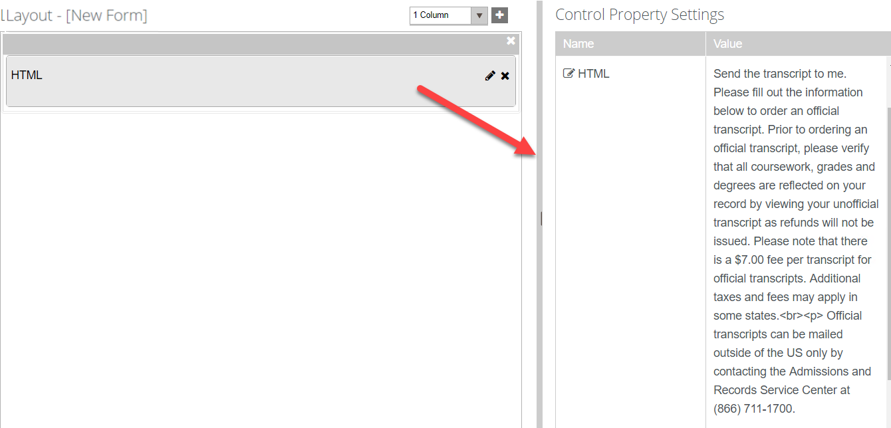

1. Click the ***+ and*** select the column option to add a ***3 Column*** panel to the ***Layout*** pane.

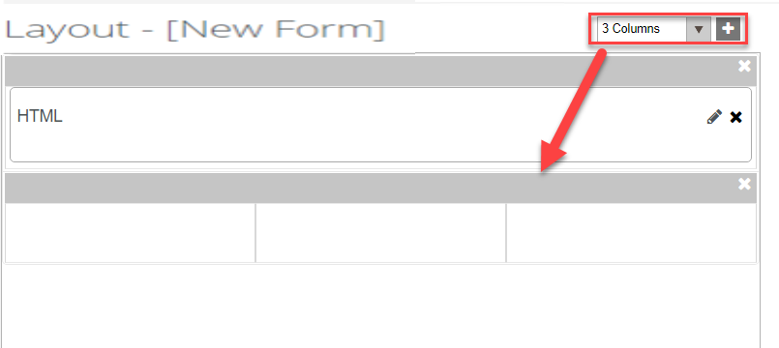

1. Select the ***Fields*** tab and under ***Student*** select the ***Student*** entity. Drag the following fields into the second panel as shown below:

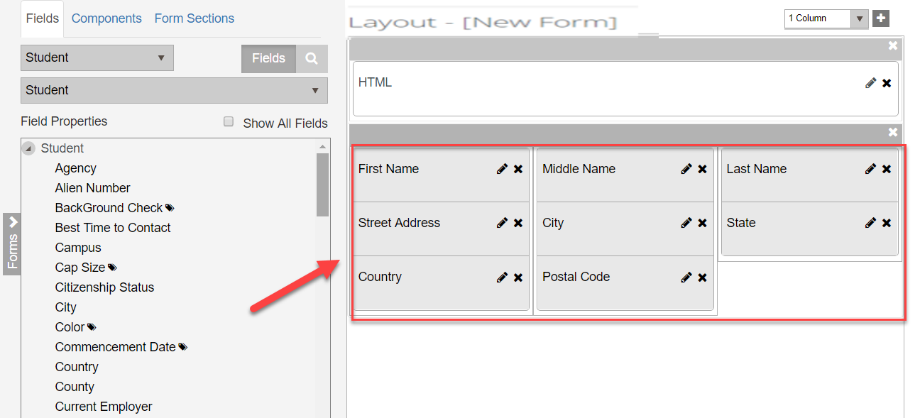

1. Make sure the ***Required*** property in the ***Control Property Settings*** pane is set to ***true*** for all of the fields except the ***Middle Name*** field.

 

1. Save and name your Form with your initials at the end as shown below.

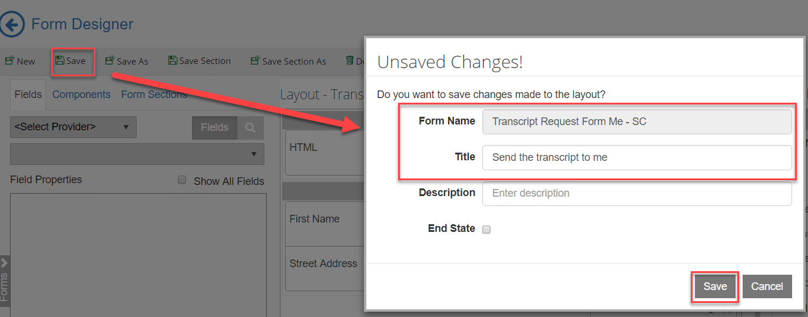

1. Select ***New.*** A ***1 Column*** panel is added to the ***Layout*** pane in the Designer.



1. Click the ***+*** and add another ***1 Column*** panel to the ***Layout*** pane.

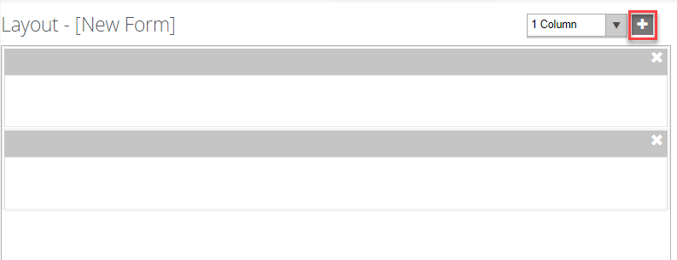

1. From the ***Components*** tab, drag an ***HTML*** component into the first panel of the ***Layout*** pane.



1. Enter the following for the ***HTML*** component in the ***HTML*** property of the ***Control Property Settings*** pane:

***<style> .navbar-default { display: none} </style>Send the transcript to an institution. Please fill out the information below to order an official transcript. Prior to ordering an official transcript, please verify that all coursework, grades and degrees are reflected on your record by viewing your unofficial transcript as refunds will not be issued. Please note that there is a $7.00 fee per transcript for official transcripts. Additional taxes and fees may apply in some states.<br><p>***

***Official transcripts can be mailed outside of the US only by contacting the Admissions and Records Service Center at (866) 711-1700.***

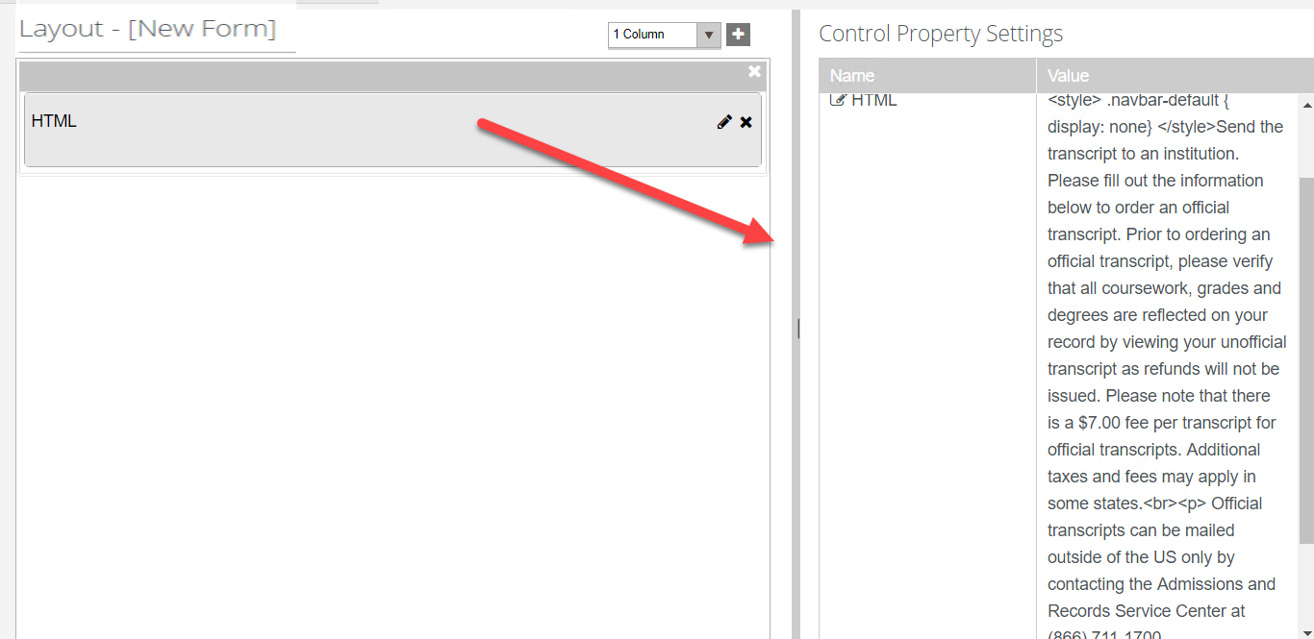

1. Select the ***Fields*** tab and select the box to ***Show All Fields.*** Select the ***Transcript Request*** entity. Drag the ***College*** field into the second panel in the ***Layout*** pane.

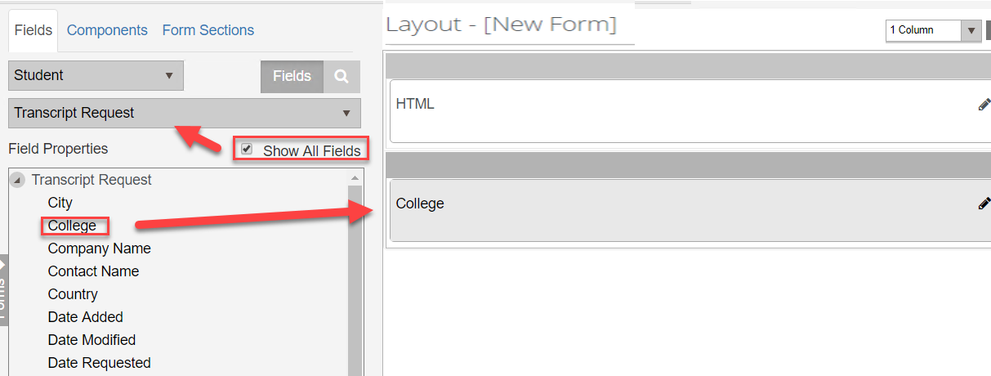

1. Update the properties for the ***College*** field in the ***Control Property Settings*** pane:

***Label- College***

***Lookup Display Member – Name (We want to display the Name of the College in our drop-down list.)***

***Lookup Query – Colleges?$select=Id,Name***

***Lookup Sort Member – Name (We want to sort our drop-down list by the College Name.)***

***Lookup Value Member – Id (We will lookup our values based on the CollegeId.)***

***Model – vm.models.transcriptRequestEntity.CollegeId***

***Option Label - <Select a College> (This will be the label on the drop-down list selector.)***

***Product – Student (This specifies the product we are querying the data from.)***

***Required – true (This makes the field required.)***

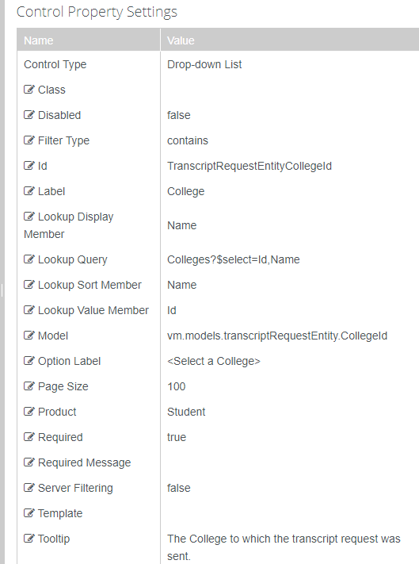

1. ***Save*** and name your Form with your initials at the end as shown below.

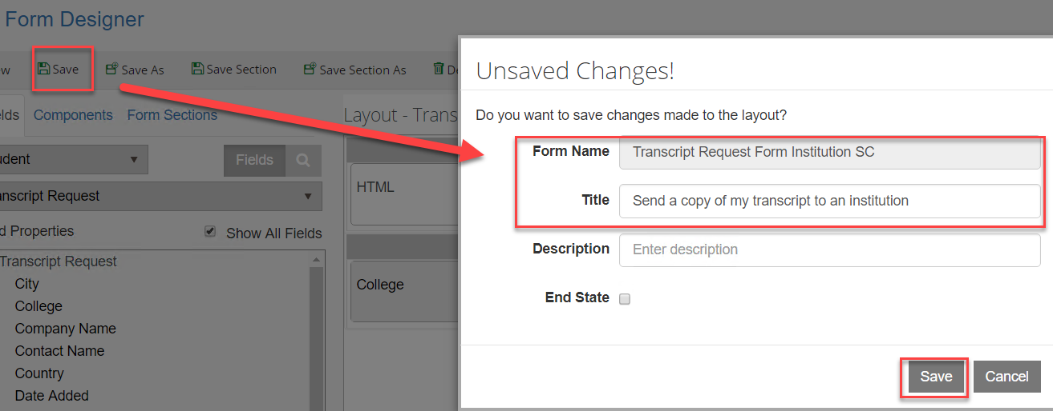

1. Select ***New.*** A ***1 Column*** panel is added to the ***Layout*** pane in the Designer.



1. Click the ***+*** and add another ***1 Column*** panel and then add a ***3 Column*** panel to the ***Layout*** pane.

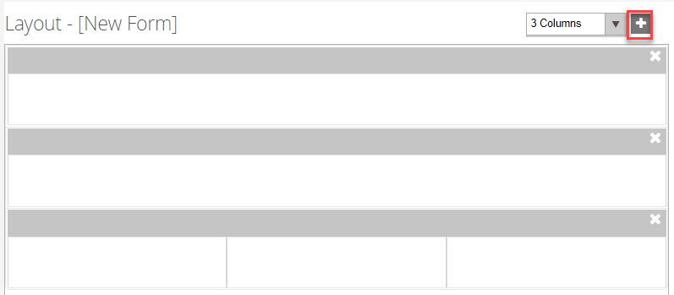

1. From the ***Components*** tab, drag an ***HTML*** component into the first panel of the ***Layout*** pane.



1. Enter the following for the ***HTML*** component in the ***HTML*** property of the ***Control Property Settings*** pane:

***<style> .navbar-default { display: none} </style>Send the transcript to a company. Please fill out the information below to order an official transcript. Prior to ordering an official transcript, please verify that all coursework, grades and degrees are reflected on your record by viewing your unofficial transcript as refunds will not be issued. Please note that there is a $7.00 fee per transcript for official transcripts. Additional taxes and fees may apply in some states.<br><p>***

***Official transcripts can be mailed outside of the US only by contacting the Admissions and Records Service Center at (866) 711-1700.***



1. Select the ***Fields*** tab and select the box to ***Show All Fields.*** Select the ***Transcript Request*** entity. Drag the ***Company Name*** and ***Contact Name*** fields into the first panel in the ***Layout*** pane. Drag the ***Street Address and Country fields into the second panel.*** Drag the City***, State*** and ***Postal Code*** into the ***third panel*** as shown below.

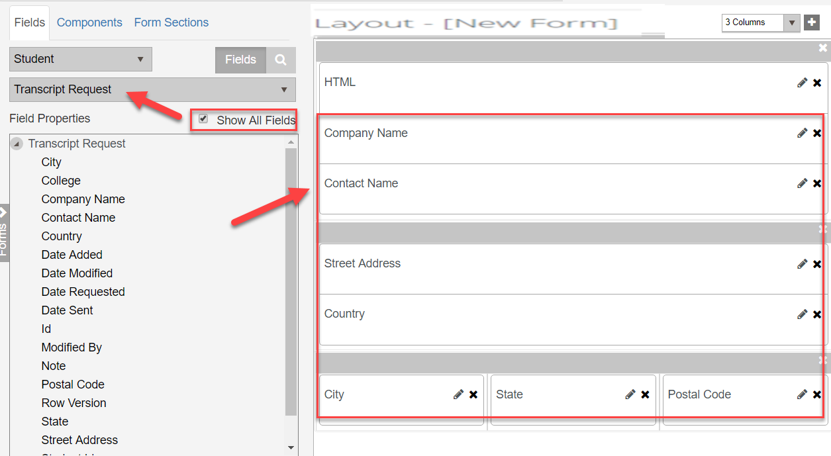

1. Make sure the ***Required*** property in the ***Control Property Settings*** pane is set to ***true*** for all of the field properties on the form.

* 

1. ***Save*** and name your Form with your initials at the end as shown below.

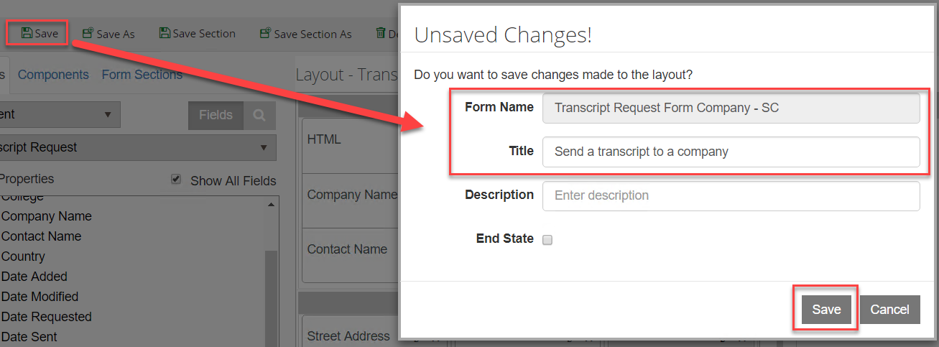

1. Change the column drop-down to ***2 Columns*** and select ***New*** to create a new form with a ***2 Column*** panel.

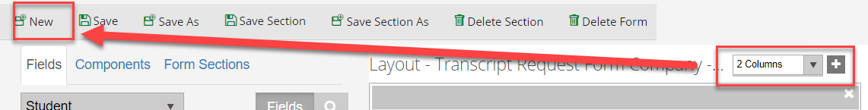

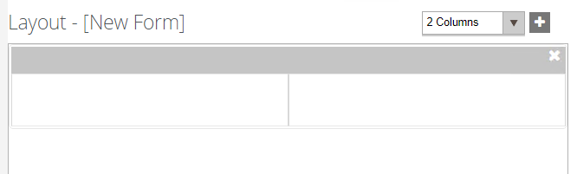

1. Add a ***3 Column*** and ***1 Column*** panel to the ***Layout*** pane.

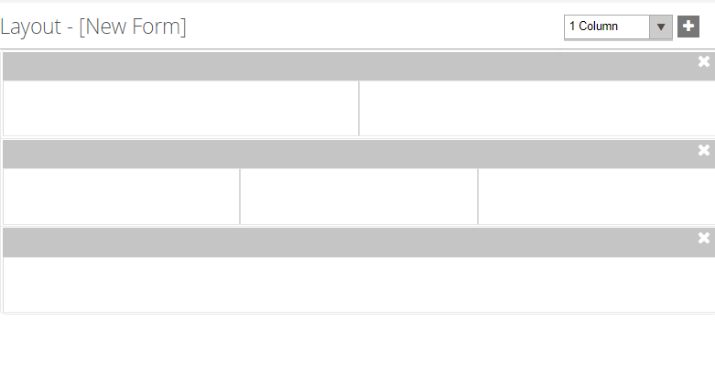

1. Select the ***Fields*** tab and under ***Student*** select the ***Student*** entity. Drag the following fields into the first panel as shown below:

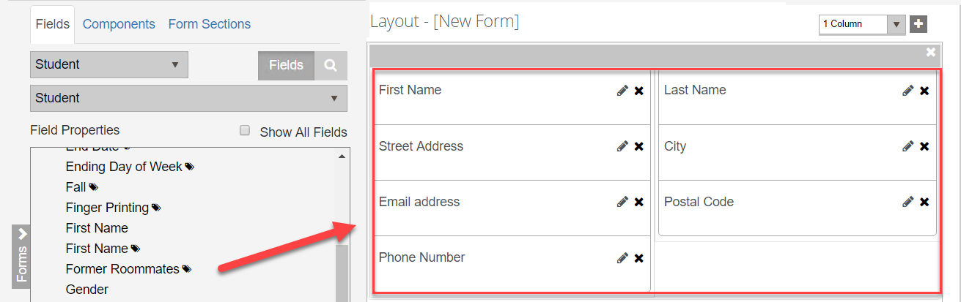

1. Make sure the ***Required*** property in the ***Control Property Settings*** pane is set to ***true*** for all of the field properties.



1. Select the ***Fields*** tab and under ***Student*** select the ***Admissions Deposit*** entity. Drag the following properties into the second panel as shown below:

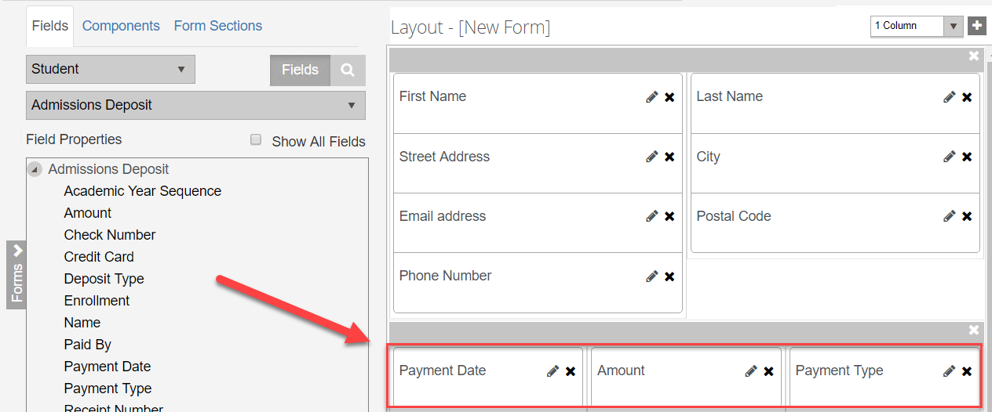

1. Make sure the ***Required*** property in the ***Control Property Settings*** pane is set to ***true*** for the ***Payment Date*** field on the form.



1. Make the ***Read-only*** property ***true*** for the ***Amount*** field.

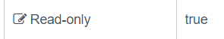

1. Make the ***Disabled*** property ***true*** for the ***Payment Type*** field.



1. From the ***Components*** tab, drag a ***Credit Card Payment*** component and an ***HTML*** component into the last panel of the ***Layout*** pane.

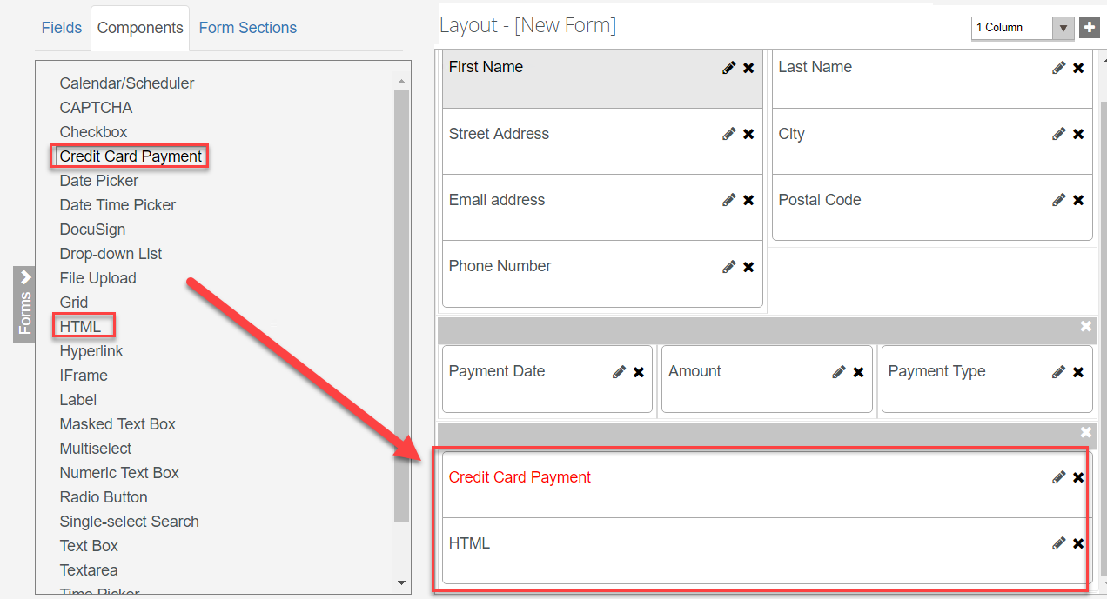

1. Update the properties for the ***Credit Card Payment*** component in the ***Control Property Settings*** pane as shown below:

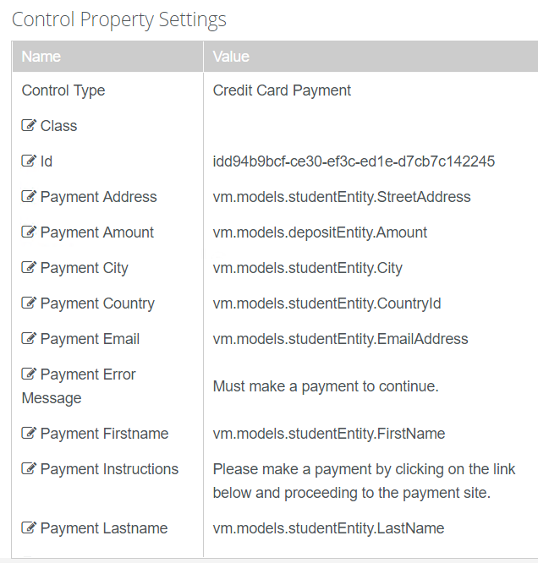

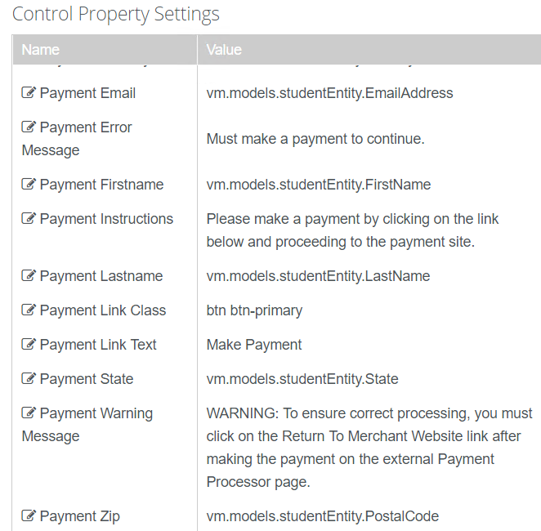

1. Enter the following for the ***HTML*** component in the ***HTML*** property of the ***Control Property Settings*** pane:

***<style> .navbar-default { display: none} </style>***

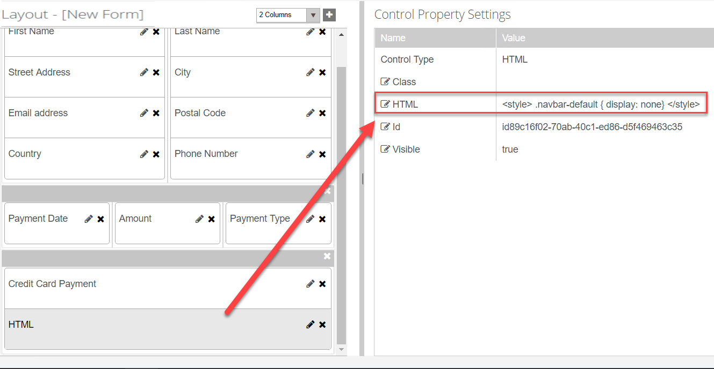

1. ***Save*** and name your Form with your initials at the end as shown below.

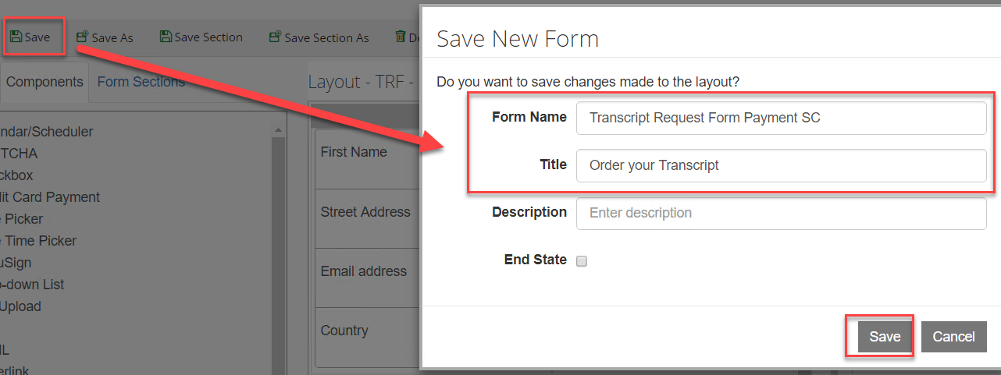

1. On the top left bar, click on the ***arrow*** to navigate out of Form Designer.

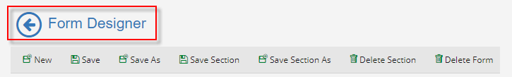

1. Select ***Sequence Designer*.**

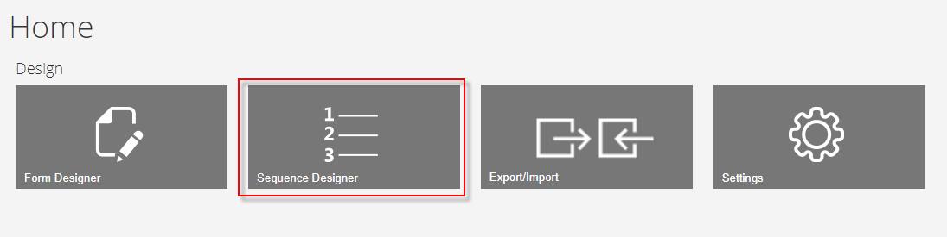

1. Select ***New*** and a new panel will be created for you to drag your forms into for creating your sequence.

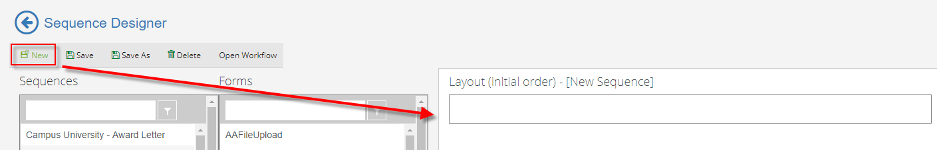

1. From the ***Forms*** column drag your forms in the ***New Sequence*** panel in the ***Layout*** pane in the order shown below.

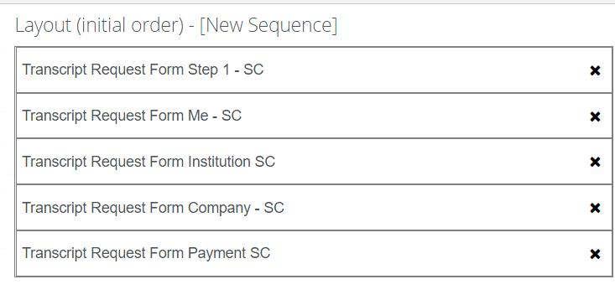

1. In the ***Properties*** pane, update the properties as shown below and select ***Save.***

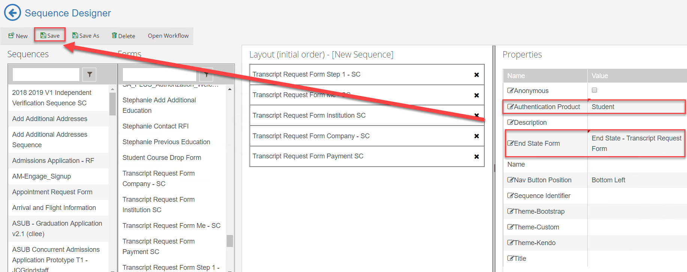

1. ***Save*** the Sequence with Your initials at the end as shown below.

**NOTE: DO NOT PUT EXTRA SPACES OR DASHES IN THE SEQUENCE NAME.**

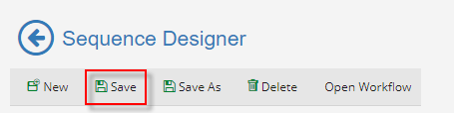

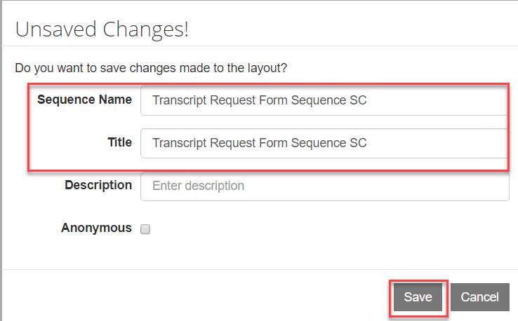

1. Once saved, select the ***Sequence*** in the ***Sequence pane*** and select ***Open Workflow*.**

**Note:** This will open Workflow Composer and create the State Machine Workflow shell for us to start creating our supporting workflow for the form. You can also open up the Workflow directly from Workflow Composer.

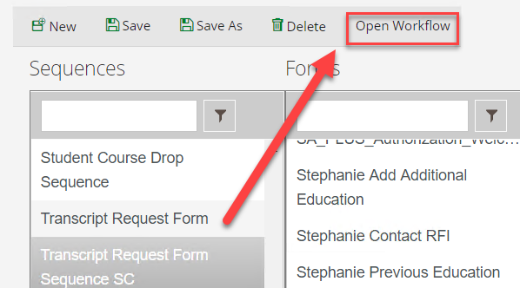

1. Rename the ***StateMachine******Flow*** to ***StateMachine-Transcript Request*.** You can do this by double-clicking on the title at the top.

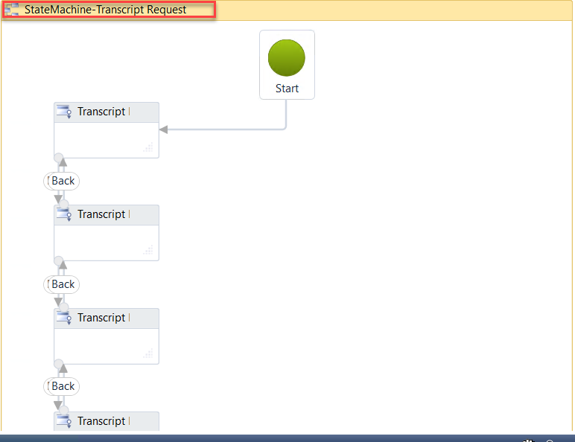

1. Select the second sequence in the state machine flow to give it the focus and hit the right arrow on your keyboard to move the sequence to the right. This helps to organize our state machine flow to better navigate.

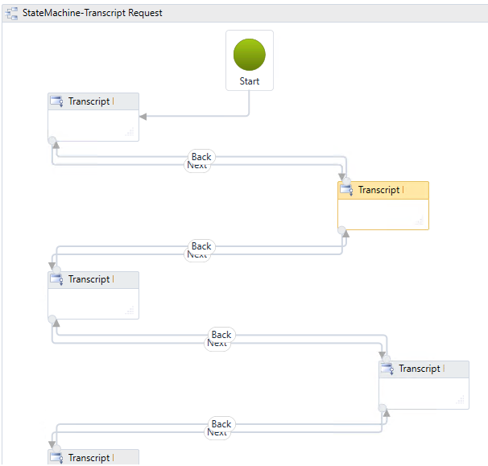

1. ***Double-click*** the first sequence in the state machine flow. This will allow you to go to the first transition in your form. We can specify in this section what we want to occur when the student enters the form.

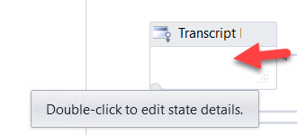

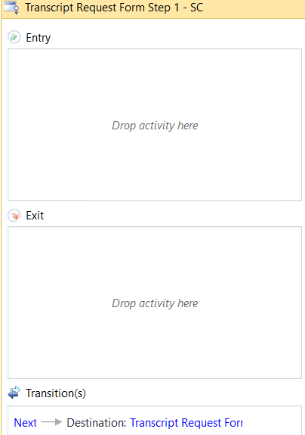

1. The first thing that we want to do is find the student that is completing the form in order to initialize the form display values back to our ***Transcript Request Form*** as needed. We will then continue finding and assigning other values that we will need for the form as the student moves through the sequence.
2. Drag a ***Sequence*** activity onto the designer in the ***Entry*** section of the activity. Rename the sequence to ***Initialize*.**

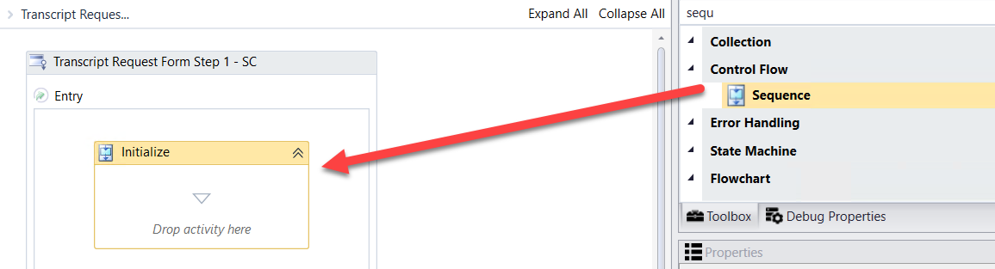

1. Drag the ***LookupUser*** activity onto the designer into the ***Sequence***. We use this activity to find the student completing the form. Rename the activity to ***Get Authenticated User*.**

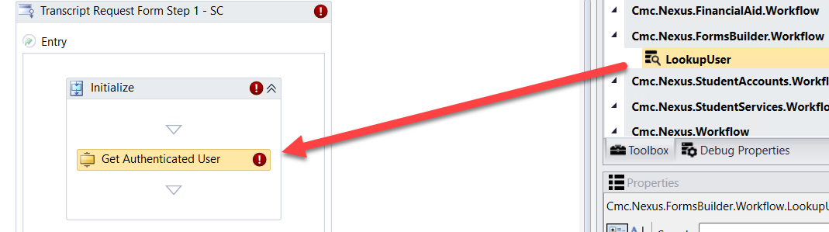

1. Create a variable:

* Name: studentid
* Variable type: Int32
* Scope: StateMachine-Transcript Request

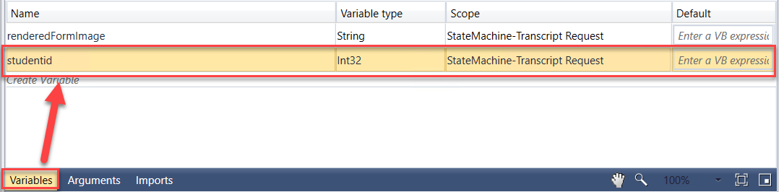

1. Complete the properties for the ***Get Authenticated User*** ***LookupUser*** activity as shown below:

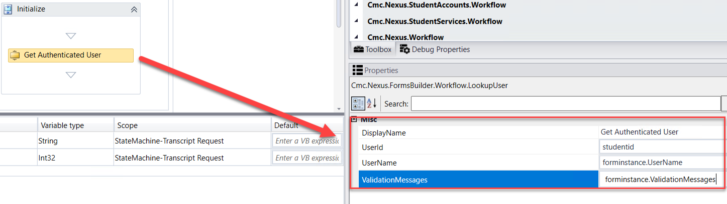

1. We then want to get the data from the ***studentEntity*** so we can display it back to our form. We use the ***GetEntity*** activity since we already have the student in the ***CampusNexus Student*** database.
2. Drag the ***GetEntity*** activity onto the designer below the ***Get Authenticated User LookupUser*** activity.

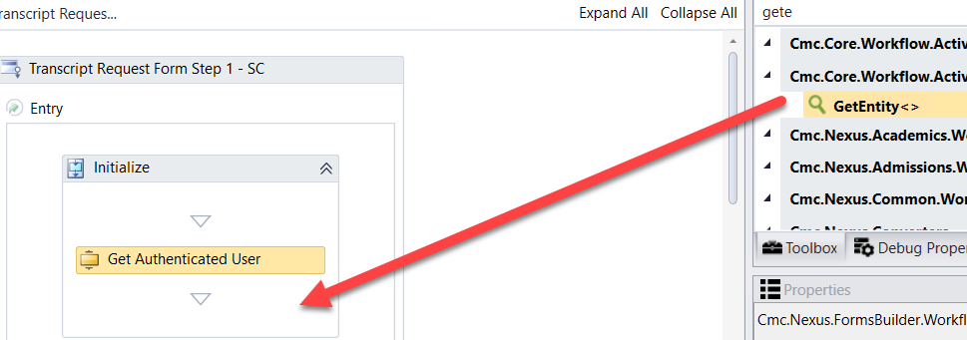

1. When the box pops up, ***Browse for Types*.**

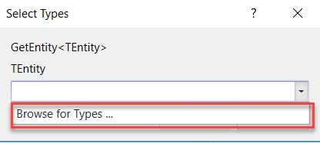

1. Navigate to: ***Cmc.Nexus.Common.Contracts>Cmc.Nexus.Common.Entities>StudentEntity and click OK***.

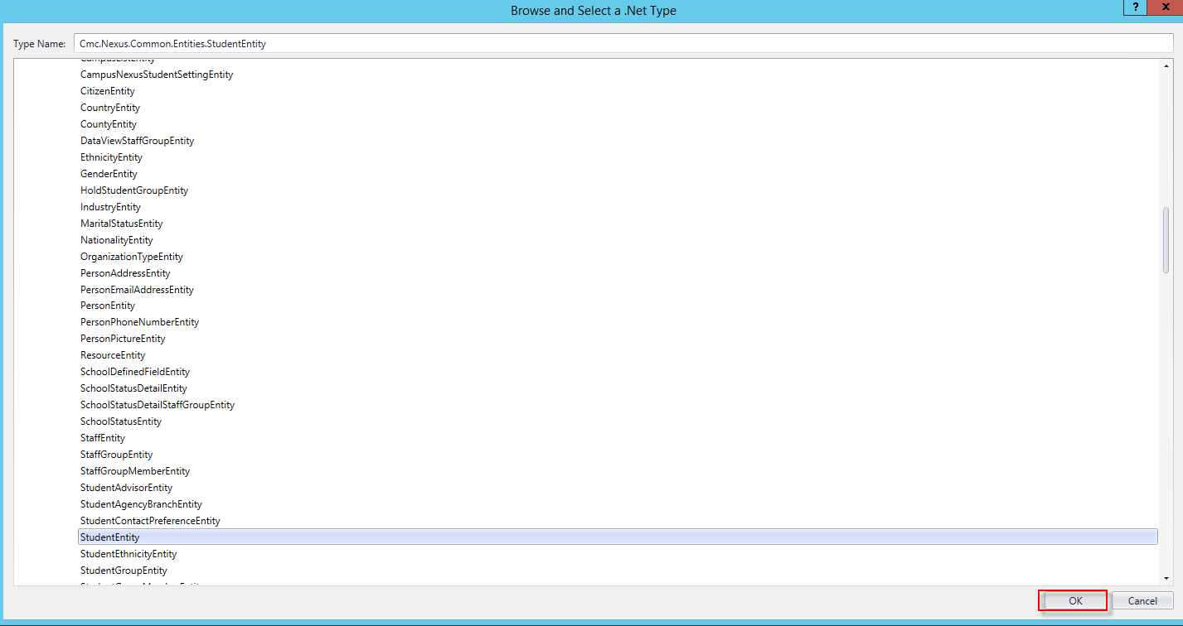

1. Specify the properties in the ***Properties pane*** for the ***GetEntity*** activity.

**Note:** The ***EntityId***is your variable of ***studentid*** and the Result is the ***studentEntity***.

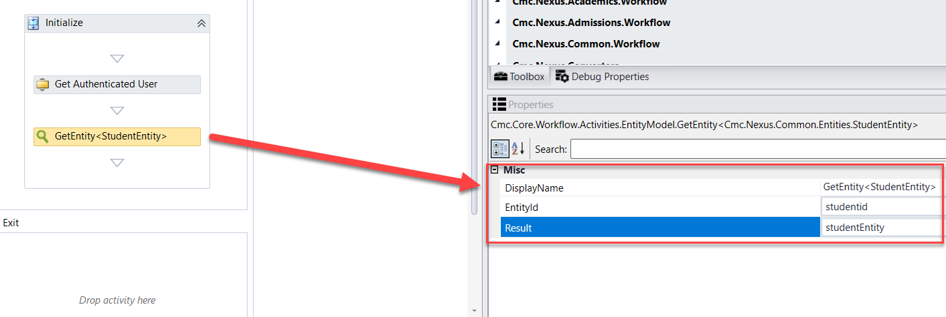

1. In our ***Transcript Request Form*** sequence, we will be collecting a fee from the student as well as updating the transcript data in ***CampusNexus Student***. We need to create those entities so once we collect the data we can save the values back to the database.
2. Drag a ***CreateEntity*** activity onto the designer below the ***GetEntity*** activity.

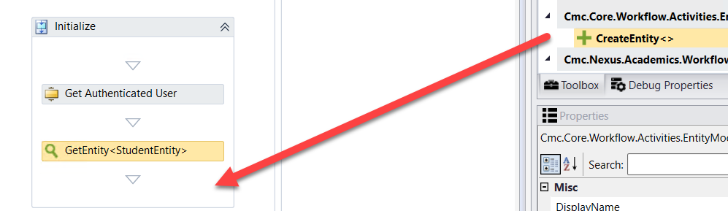

1. When the box pops up, ***Browse for Types*.**

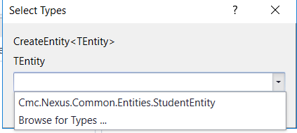

1. Navigate to: ***Cmc.Nexus.Admissions.Contracts>Cmc.Nexus.Admissions.Entities>DepositEntity and click OK***.

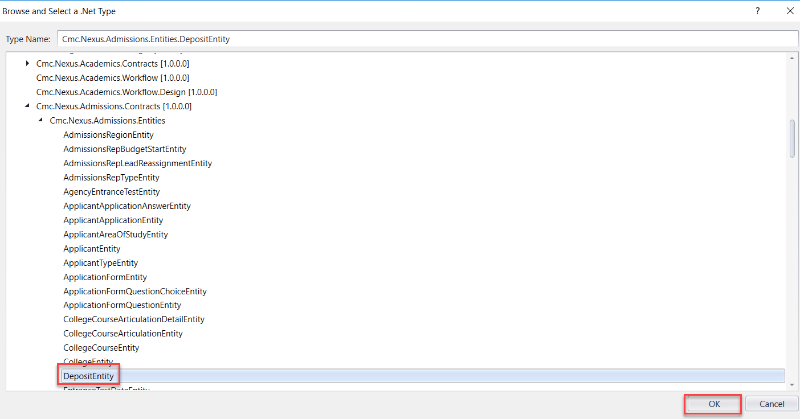

1. Specify the properties in the ***Properties pane*** for the ***CreateEntity*** activity.

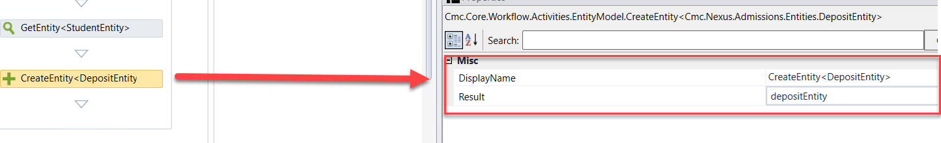

1. Drag a ***CreateEntity*** activity onto the designer below the previous ***CreateEntity*** activity.

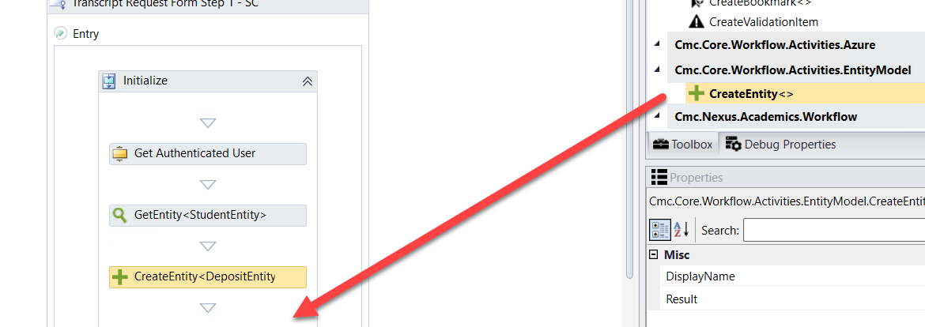

1. When the box pops up, ***Browse for Types*.**

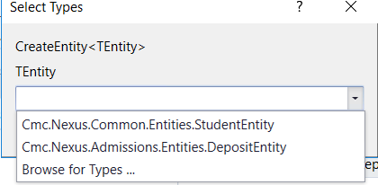

1. Navigate to: ***Cmc.Nexus.CRM.Contracts>Cmc.Nexus.CRM.Entities>TranscriptRequestEntity and click OK***.

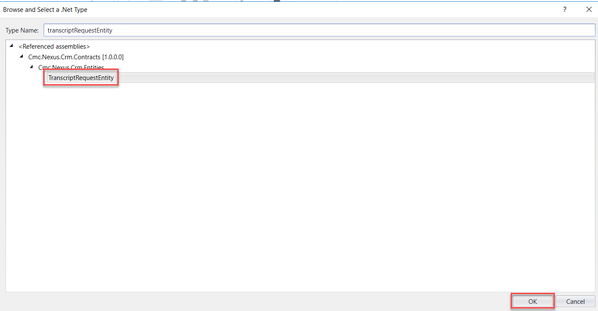

1. Specify the properties in the ***Properties pane*** for the ***CreateEntity*** activity.

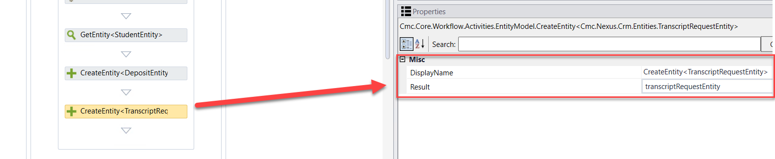

1. Drag two ***Assign*** activities onto the Designer below the previous ***CreateEntity*** activity. Update the properties as follows:

* ***Display Name***:  ***Assign Transcript Amount Received***; ***depositEntity.DepositReceivedDate = datetime.Now***
* ***Display Name: Assign Transcript Amount;***

***depositEntity.Amount = 7.00d***

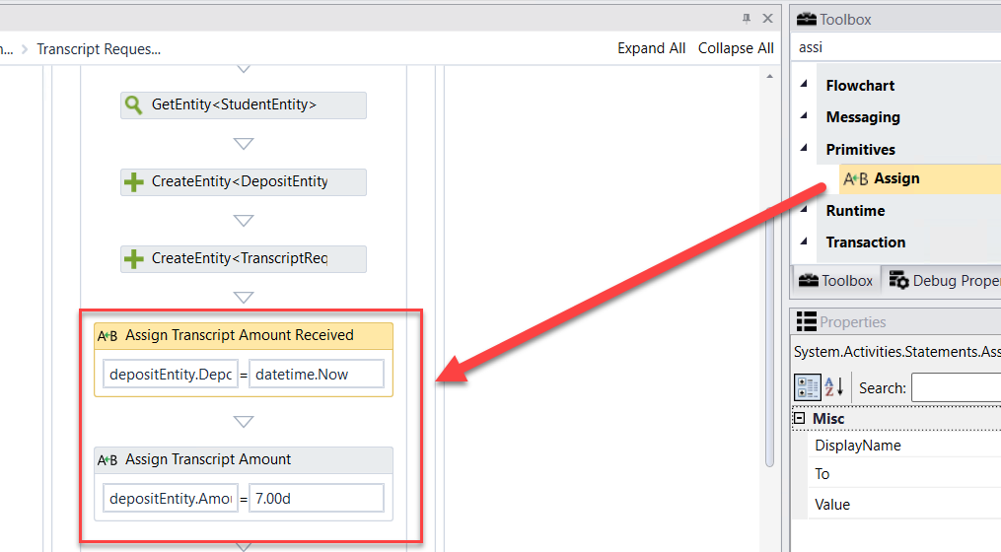

1. Click ***Next*** at the bottom of the form to enter the next transition of your ***Transcript Request Form***.

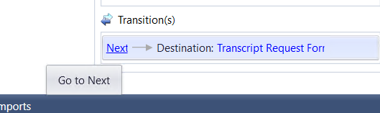

1. On our ***Transcript Request Form Step 1,*** we have three radio buttons to allow the student to specify where to send the transcript. When we designed our form, we bound each radio button to a model called ***vm.models.Request.*** We also assigned a default value to each radio button (1,2,3). In this section, we need to create an argument to bind to the model and we also need to route the student to the different forms in the sequence based on which radio button was selected.

Create an argument as shown below:

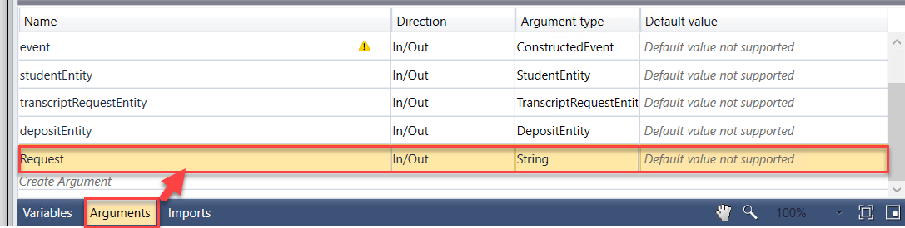

1. Change the transition wording from ***Next*** to ***T1*** and as the ***Condition*** enter ***Request="1".*** If the student selects to send the transcript to themselves (1), then the ***Transcript Request Form Me*** will be next in the sequence.

Click to ***Add shared trigger transition.***

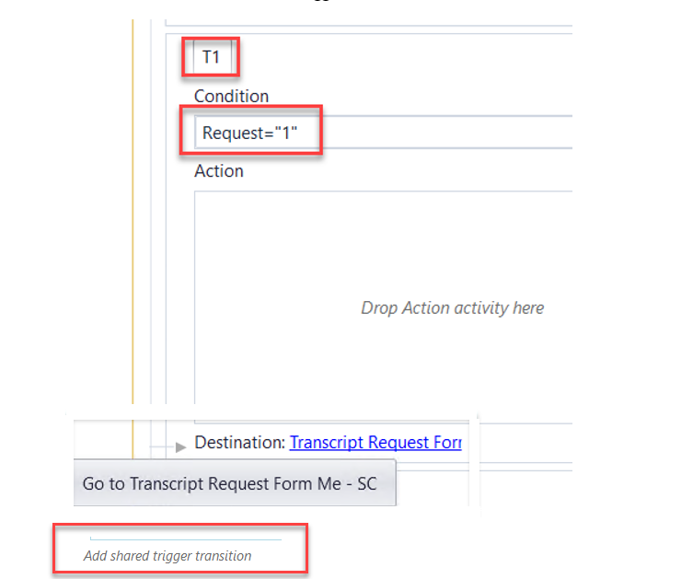

1. Select ***Transcript Request Form Institution*** as the next transition.

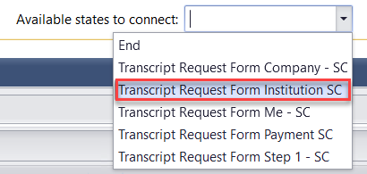

1. Transition ***T2*** is automatically created. For the ***Condition*** enter ***Request="2".*** If the student selects to send the transcript to an Institution (2), then the ***Transcript Request Form Institution*** will be next in the sequence. Click to ***Add shared trigger transition.***

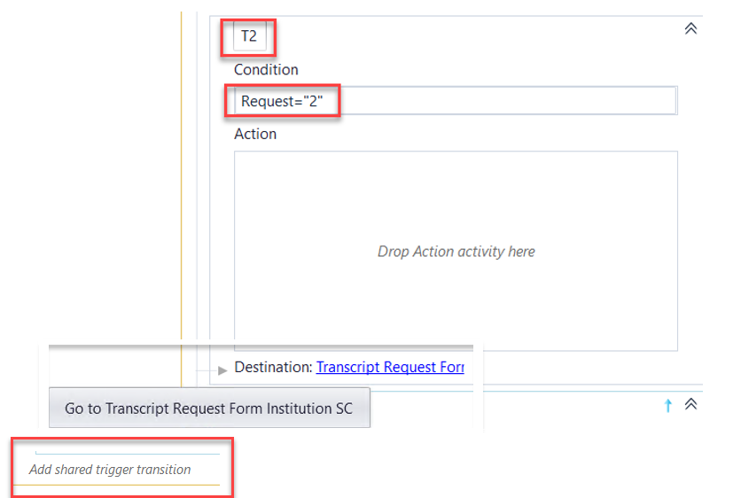

1. Select ***Transcript Request Form Company*** as the next transition.

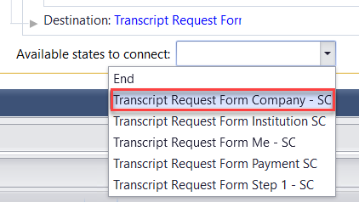

1. Transition ***T3*** is automatically created. For the ***Condition*** enter ***Request="3".*** If the student selects to send the transcript to a Company (3), then the ***Transcript Request Form Company*** will be next in the sequence

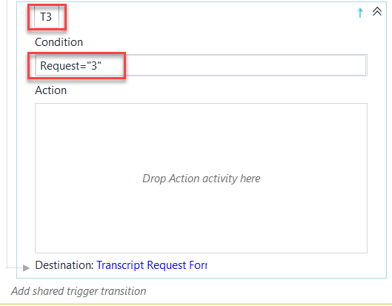

1. Drag three ***Assign*** activities into the ***Action*** section of the ***T1*** transition. Rename the ***Sequence*** that is automatically created around the ***Assign*** activities to: ***Request is Student – Assign Values.*** Update the properties for the ***Assign*** activities as follows:

* ***Display Name: Assign Type if Me; transcriptRequestEntity.TranscriptType = "S"***
* ***Display Name: Assign Student First Name; transcriptRequestEntity.CompanyName = studentEntity.FirstName***
* ***Display Name: Assign Student Last Name; transcriptRequestEntity.ContactName = studentEntity.LastName***

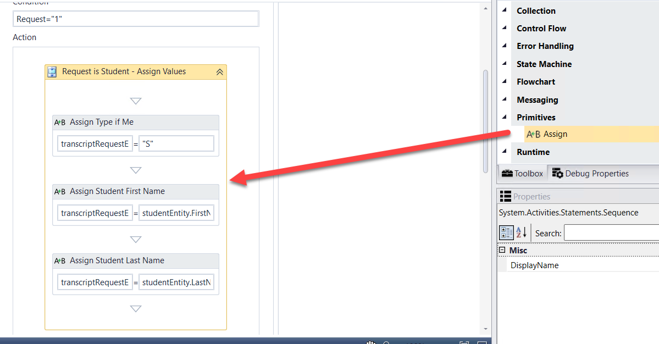

1. Drag an ***Assign*** activity into the ***Action*** section of the ***T2*** transition. Update the properties for the ***Assign*** activity as follows:

* ***Display Name: Assign Type if Institution; transcriptRequestEntity.TranscriptType = "C"***

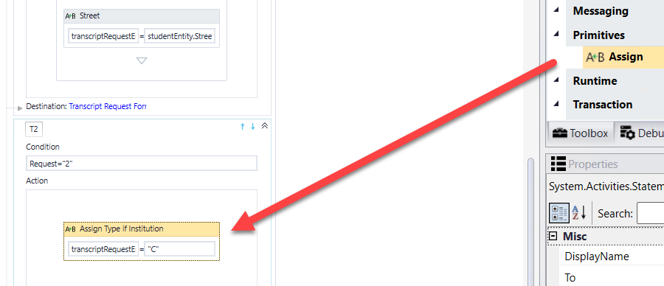

1. Drag an ***Assign*** activity into the ***Action*** section of the ***T3*** transition. Update the properties for the ***Assign*** activity as follows:

* ***Display Name: Assign Type if Company; transcriptRequestEntity.TranscriptType = "O"***

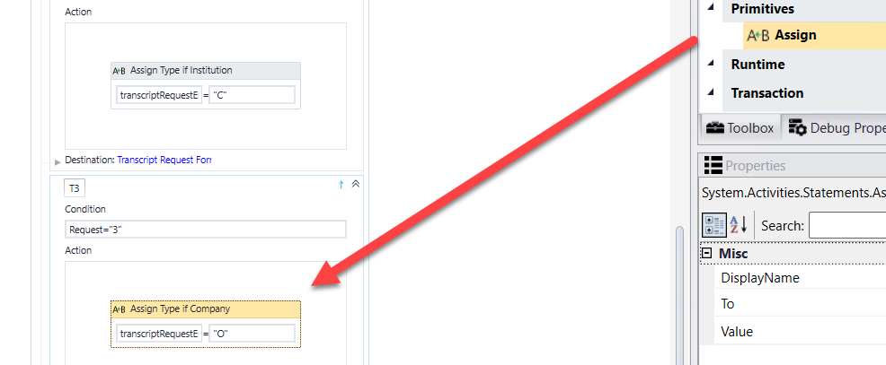

1. Click in the cookie-trail in the top left of the Designer to return to your main State Machine Workflow.

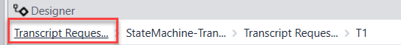

1. We need to clean up our workflow a bit to ensure the flow is how we want it to happen. First, we need to delete all of the ***Back*** transitions in the workflow. Select the back lines to give them the focus and select delete on your keyboard.

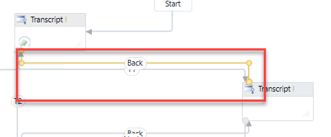

Your workflow should now look similar to the below screenshot.

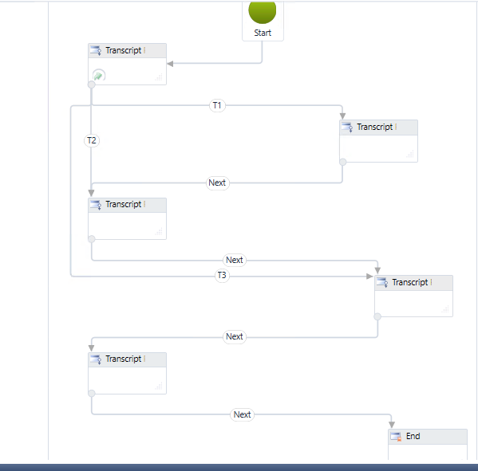

1. Now we need to move all of our ***Next*** transition endpoints to the last sequence in our ***Transcript Request Form*** sequence before the ***End*** state.

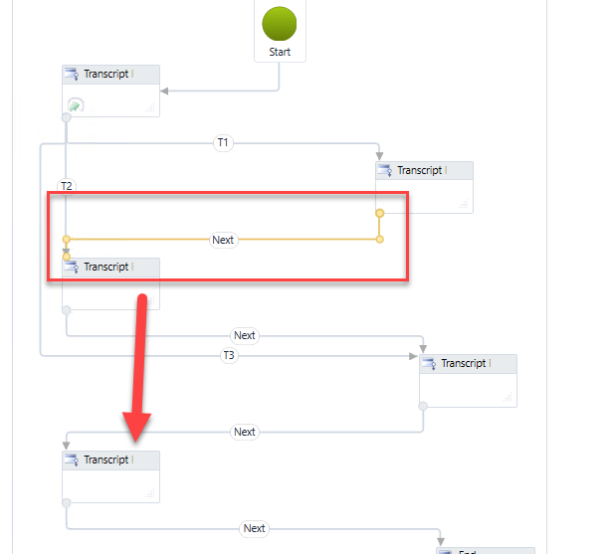

Your workflow should now look similar to the below screenshot.

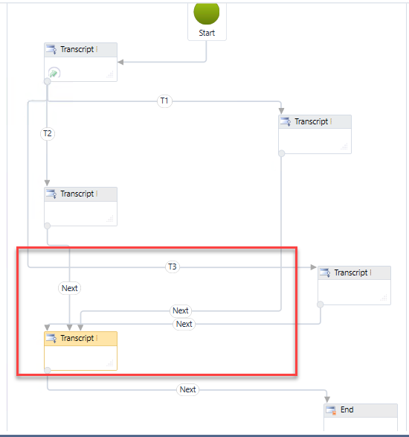

1. We need to add some logic to the ***Transcript Request Form Me*** transition. Double-click in the ***Transcript Request Form Me*** sequence to go to the entry of the transition for the sequence.

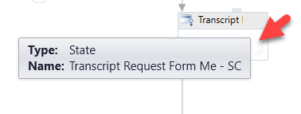

1. Select ***Next*** to go to the transition.

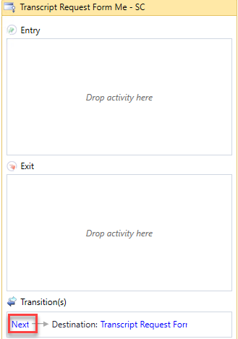

1. Drag an ***Assign*** activity below the ***Next WaitforFormBookmark*** activity. Update the properties for the ***Assign*** activity as follows:

* ***Display Name: Assign Address Association; studentEntity.StudentAddressAssociation = Cmc.Nexus.Common.Entities.StudentAddressAssociation.IgnoreInStudentAssociation***
* Rename the ***Sequence*** activity that was automatically created to: ***Save and Next***

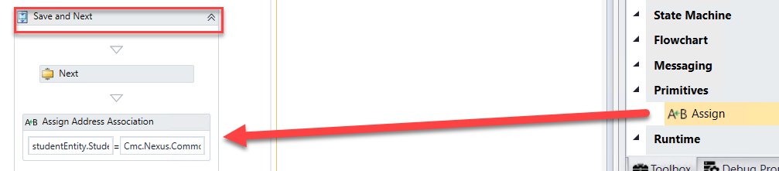

1. Drag the ***SaveEntity*** activity onto the designer below the ***Assign Address Association Assign*** activity.

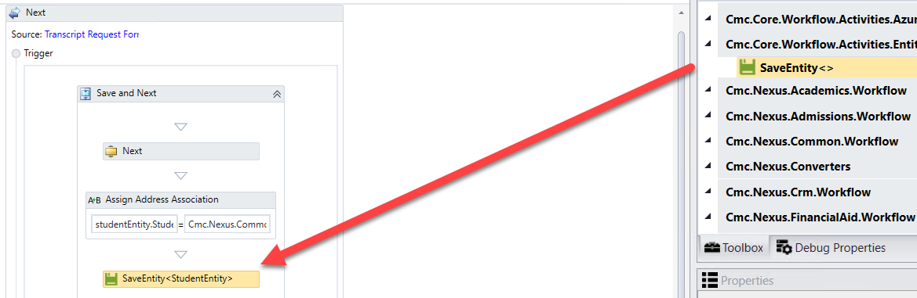

1. When the box pops up, ***Browse for Types*.**



1. ***Navigate to: Cmc.Nexus.Common.Contracts>Cmc.Nexus.Common.Entities>StudentEntity and click OK.***



1. Specify the properties in the ***Properties pane*** for the ***SaveEntity*** activity.

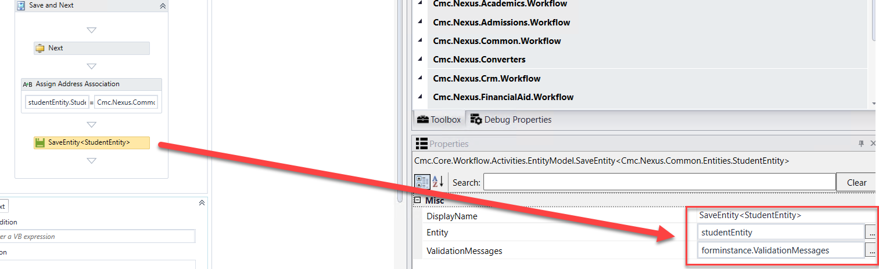

1. We now want to put our final logic in our workflow. At the bottom of the ***Transcript Request Form Me*** transition click to go to the ***Transcript Request Form Payment*** sequence.

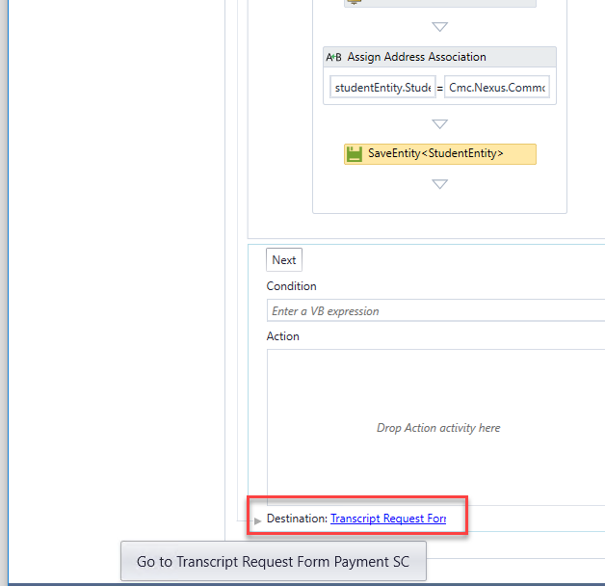

1. Drag an ***Assign*** activity into the ***Entry*** section of the sequence transition. Update the properties for the ***Assign*** activity as follows:

* ***Display Name: Assign Payment Type Credit Card; depositEntity.PaymentType = "Credit Card"***
* Select ***Next*** to go to the transition.

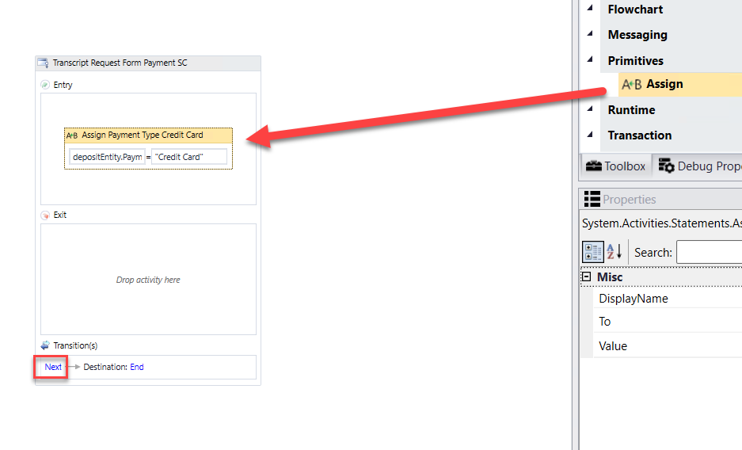

1. Rename the ***WaitForFormBookmark*** activity and the Next button transition text to ***Continue***.

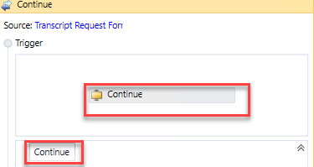

1. Drag an ***If*** activity below the ***WaitForFormBookmark*** activity. Rename the activity and the sequence that was created around both activities to ***Verify Payment Info.*** Enter the following for the ***Condition*** of the ***If*** activity:

***String.IsNullOrEmpty(forminstance.PaymentInfo.TransactionId)***

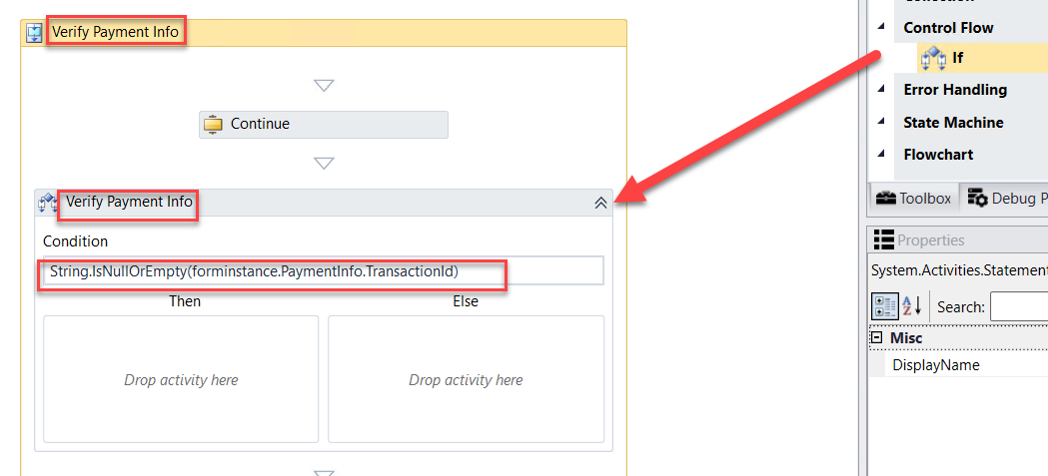

1. Drag a ***CreateValidationItem*** activity into the ***Then*** section of the ***Verify Payment Info If*** activity. Update the following properties for the activity:

* ***Message: "Something went wrong with the payment processing. Please contact customer service to confirm that your payment was processed correctly."***
* ***Messages: forminstance.ValidationMessages***

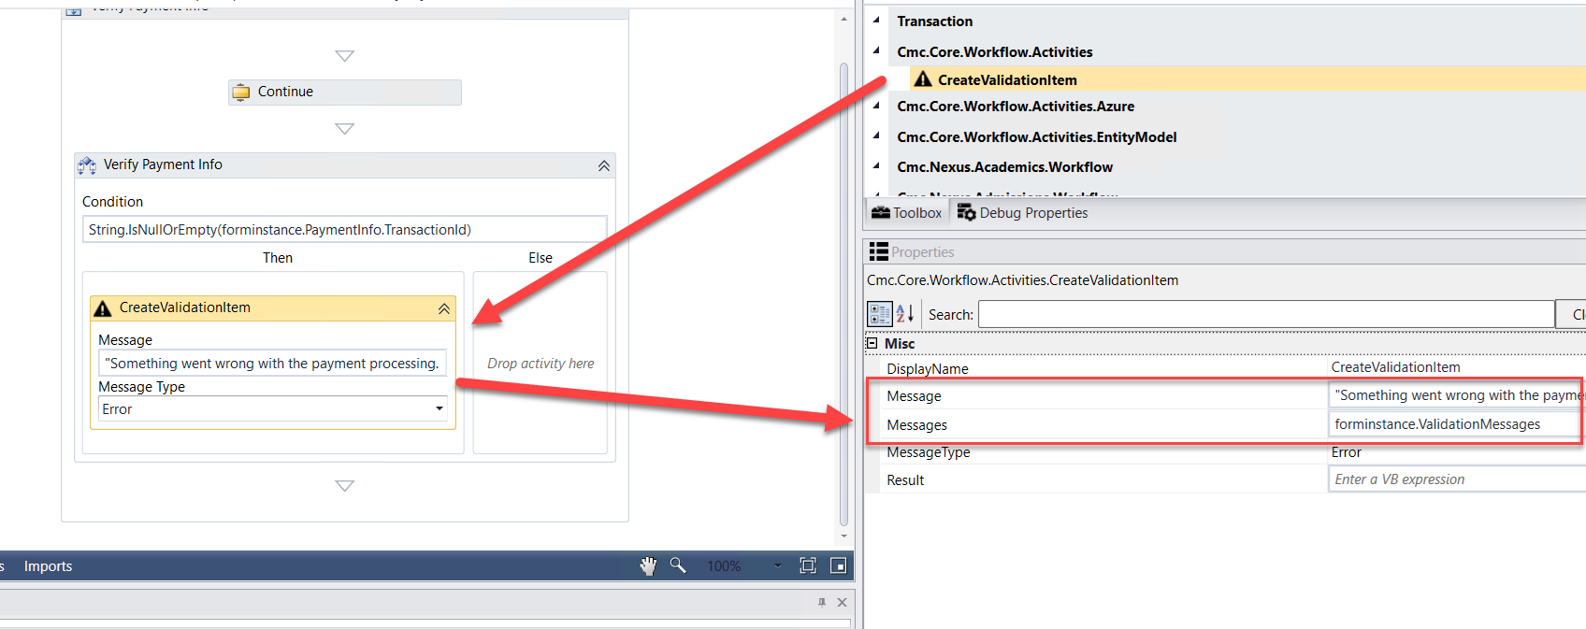

1. Drag the ***VerifyCardPayment*** activity below the ***Verify Payment Info If*** activity. Update the properties for the activity as shown below:

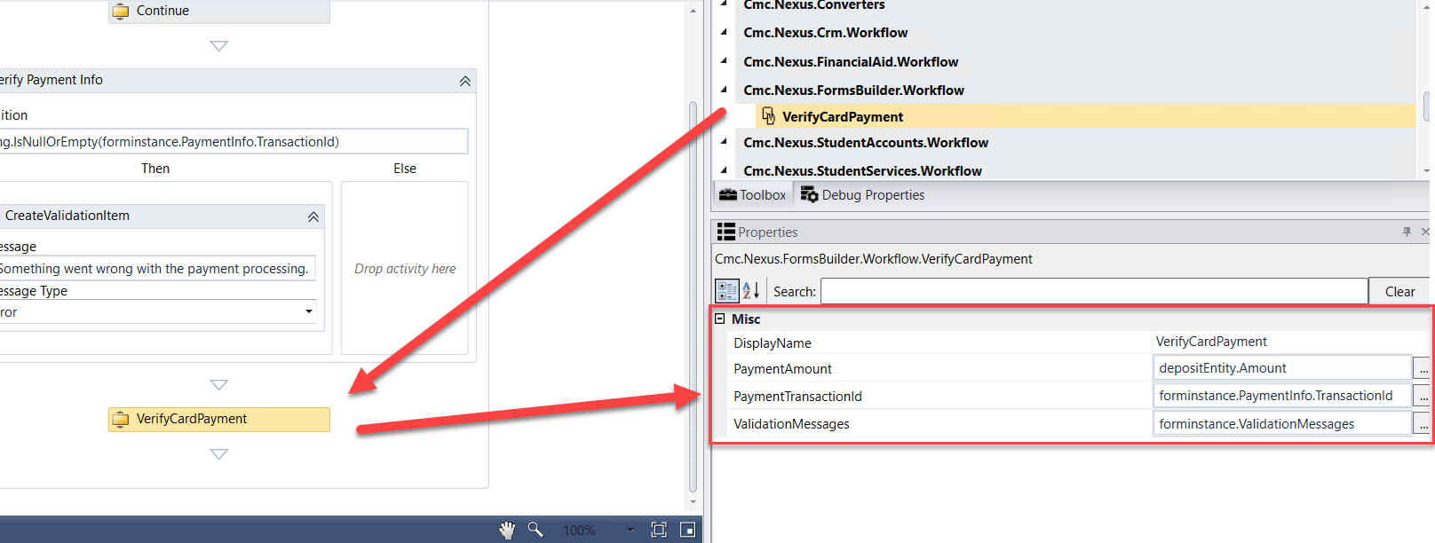

1. Select the ***Continue WaitForFormBookmark*** activity and update the ***TransitionType*** property to ***MoveForward.***

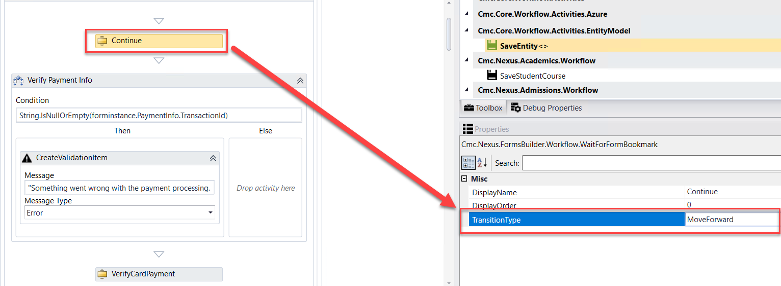

1. Enter the following for the ***Condition*** in your transition.

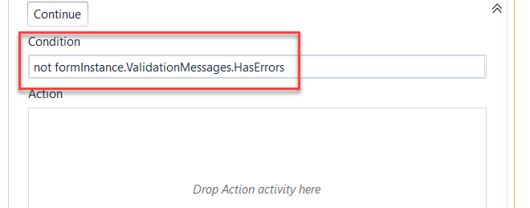

1. Drag a ***Sequence*** activity into the ***Action*** section of your transition. Rename the activity to ***Process Request.***

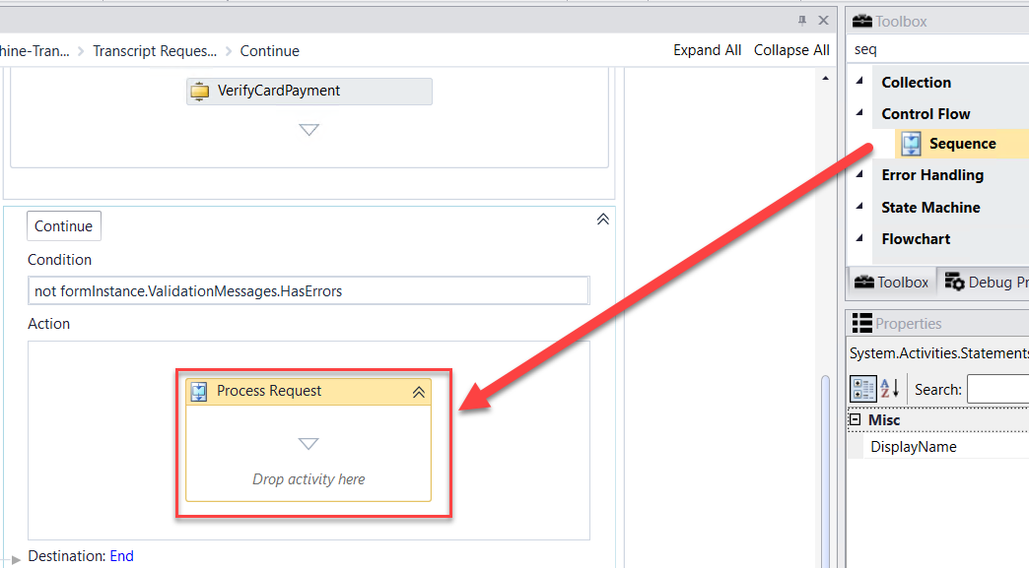

1. Drag three ***Sequence*** activities into the ***Process Request Sequence*** activity. Rename each activity as shown below.

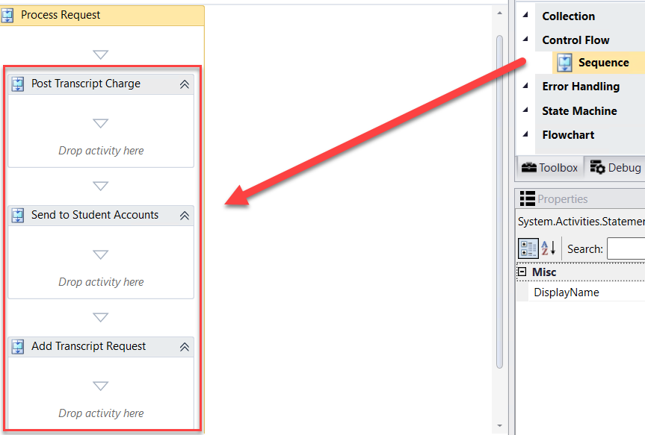

1. Drag the ***LookupCurrentEnrollmentPeriod*** activity into the ***Post Transcript Charge*** sequence. Rename the activity to ***Get Enrollment ID.***

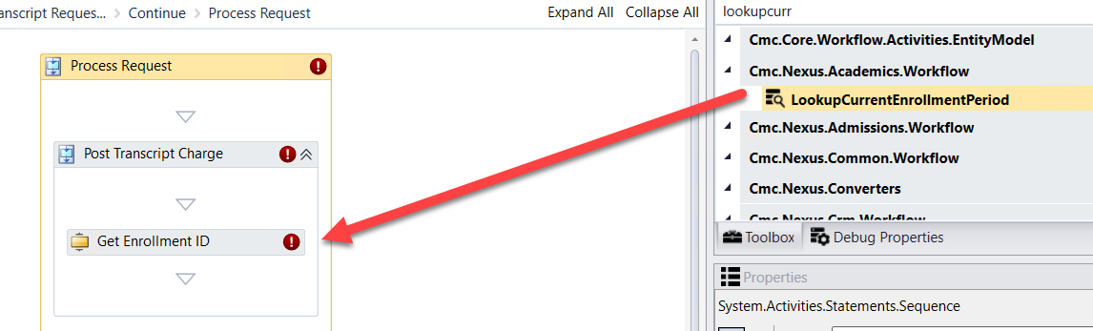

1. Create a ***variable:***

* Name: ***currEnroll***
* Variable type:  ***StudentEnrollmentPeriodEntity (You will need to browse for Cmc.Nexus.Academics.Contracts>Cmc.Nexus.Academics.Entities>StudentEnrollmentPeriodEntity)***
* Scope: ***StateMachine-Transcript Request***

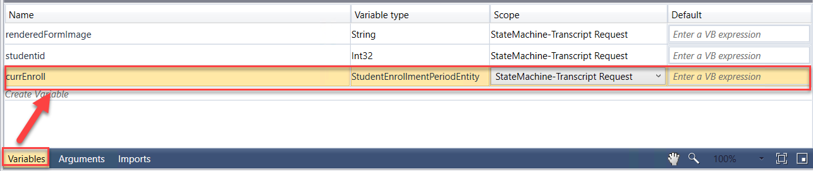

1. Complete the properties for the ***Get Enrollment ID LookupCurrentEnrollmentPeriod*** activity as shown below.

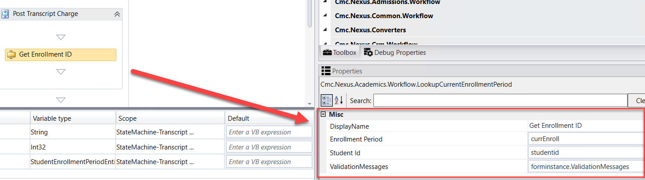

1. Drag the ***CreateCharge*** activity located under the ***Cmc.Nexus.StudentAccounts.Workflow*** entity in the ***Toolbox*** below the ***Get Enrollment ID LookupCurrentEnrollmentPeriod*** activity. Complete the properties as shown below:

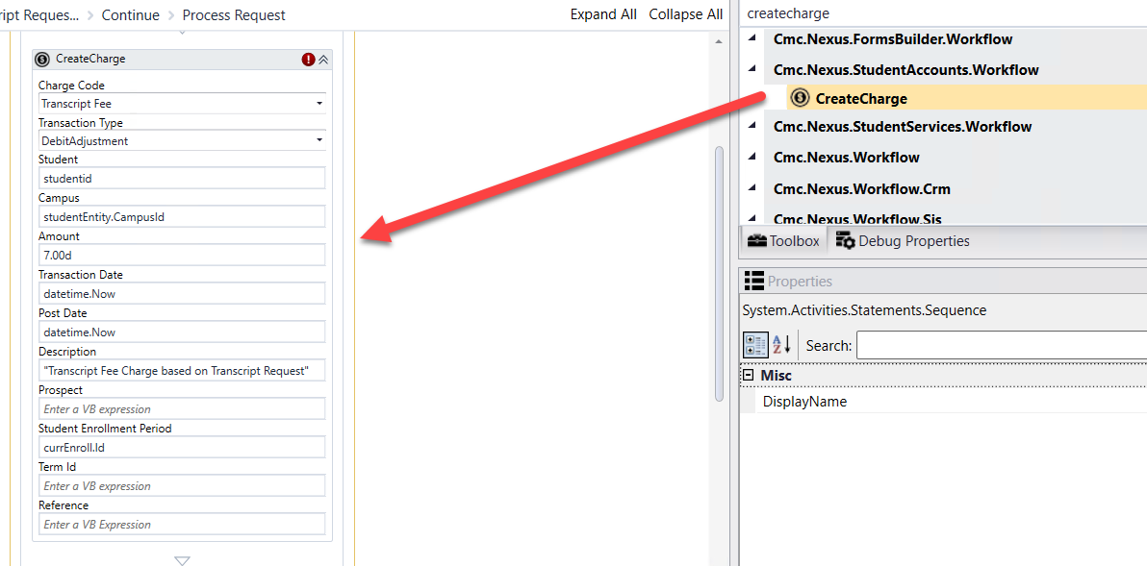

1. Create a ***variable:***

* Name: ***Fee***
* Variable type: ***StudentAccountTransactionEntity*** (You will need to browse for ***Cmc.Nexus.StudentAccounts.Contracts>Cmc.Nexus.StudentAccounts.Entities>StudentAccountTransactionEntity***)
* Scope: ***StateMachine-Transcript Request***

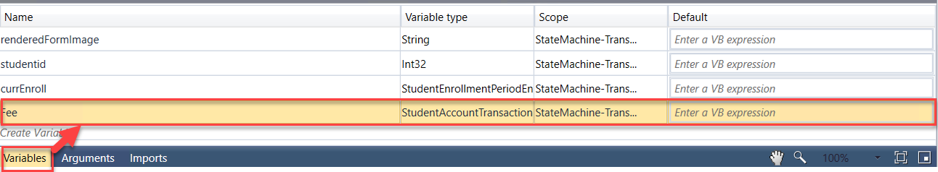

1. Assign the ***Fee*** variable to the ***Charge*** property for the ***CreateCharge*** activity.

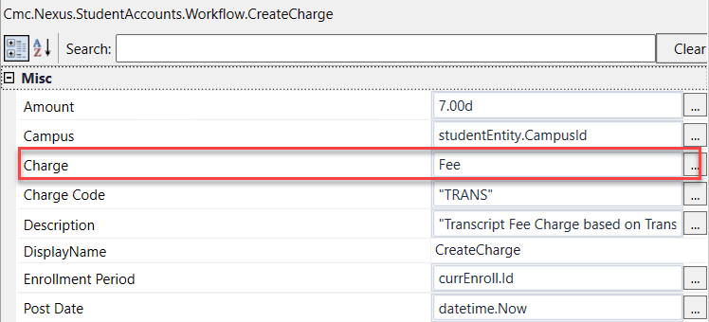

1. Drag the ***SaveCharge*** activity located under the ***Cmc.Nexus.StudentAccounts.Workflow*** entity in the ***Toolbox*** below the ***CreateCharge*** activity. Update the properties for the activity as shown below.

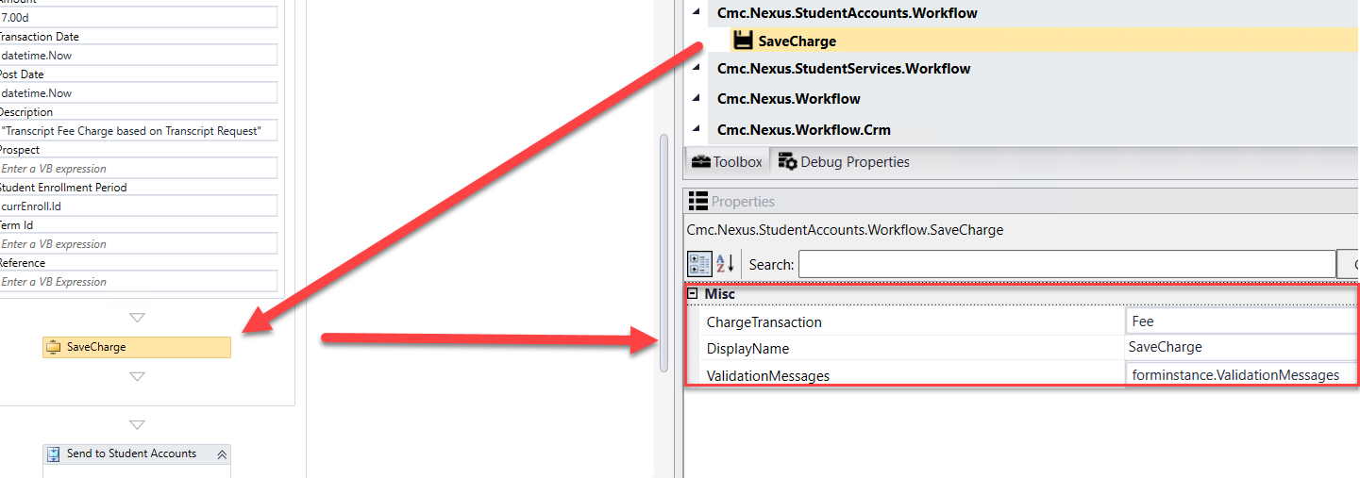

1. Drag the ***GetServiceInstance<>*** activity into the ***Send to Student Accounts*** sequence.

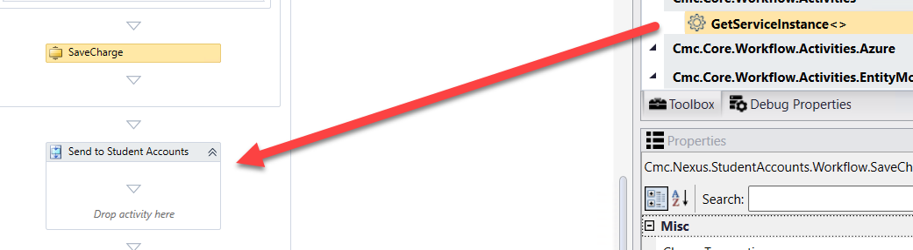

1. When the box pops up, ***Browse for Types*.**



1. Navigate to: ***Cmc.Nexus.StudentAccounts.Contracts>Cmc.Nexus.StudentAccounts.Services>IStudentAccountTransactionService and click OK***.

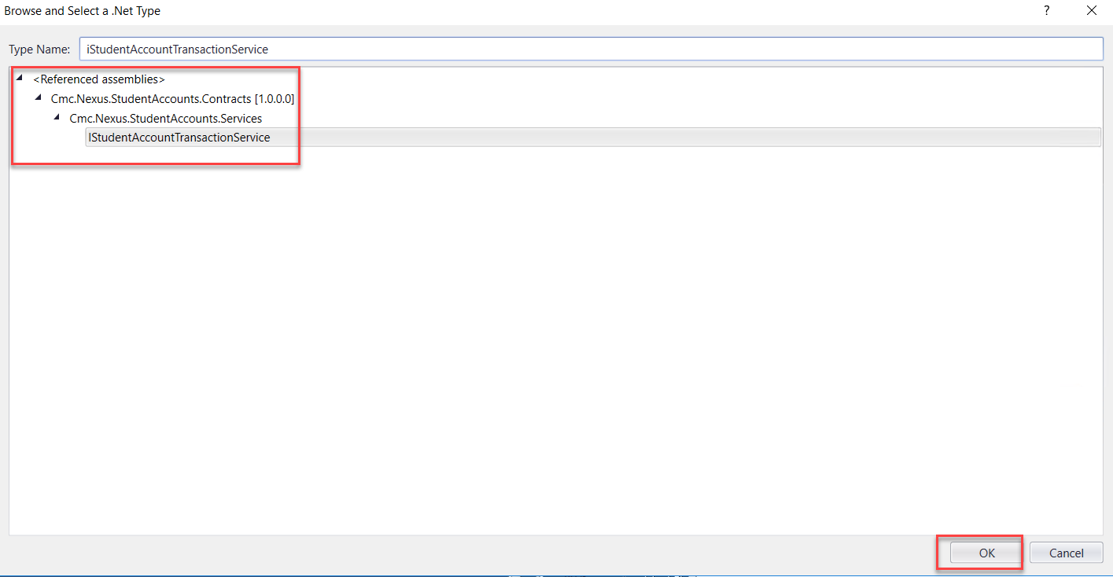

1. Create a ***variable:***

* Name: ***AcctSvc***
* Variable type: ***IStudentAccountTransactionService (You will need to browse for Cmc.Nexus.StudentAccounts.Contracts>Cmc.Nexus.StudentAccounts.Services> IStudentAccountTransactionService)***
* Scope: ***StateMachine-Transcript Request***

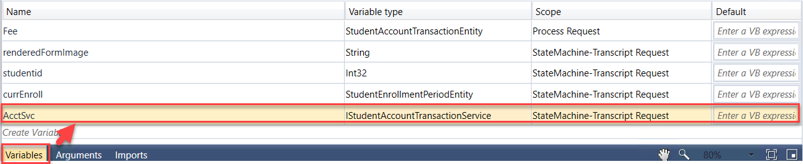

1. Update the properties for the ***GetServiceInstance<>*** activity as shown below.

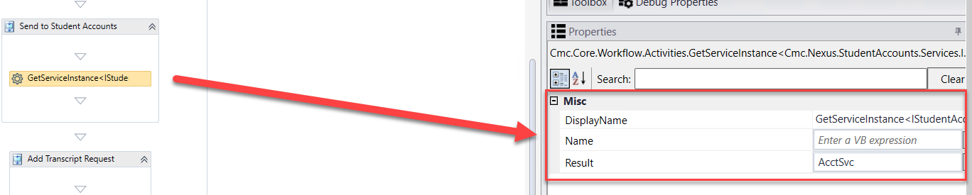

1. Create the following variables:
2. ***Variable***:

* Name: ***postRequest***
* Variable type: ***PostAccountTransactionPaymentRequest (You will need to browse for Cmc.Nexus.StudentAccounts.Contracts>Cmc.Nexus.StudentAccounts.Services>PostAccountTransactionPaymentRequest)***
* Scope: ***StateMachine-Transcript Request***
* Default: ***new PostAccountTransactionPaymentRequest***

1. ***Variable***:

* Name: ***postResponse***
* Variable type: ***PostAccountTransactionPaymentResponse (You will need to browse for Cmc.Nexus.StudentAccounts.Contracts>Cmc.Nexus.StudentAccounts.Services>PostAccountTransactionPaymentResponse)***
* Scope: ***StateMachine-Transcript Request***

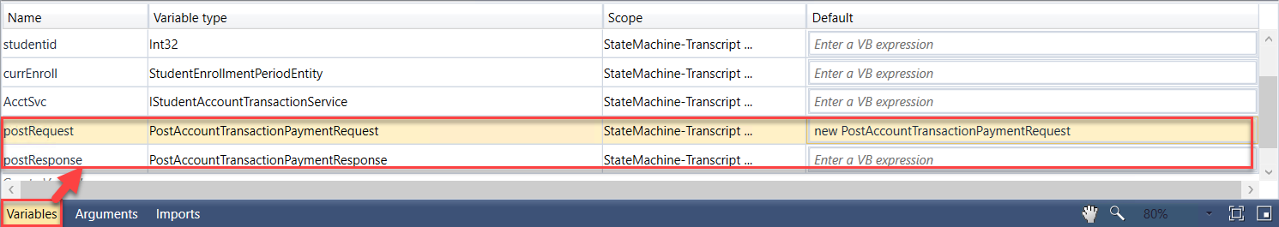

1. Drag seven ***Assign*** activities below the ***GetServiceInstance<>*** activity. Update the properties for the activities as follows:

* ***Display Name: Assign Student ID; postRequest.StudentId = studentid***
* ***Display Name: Assign Amount; postRequest.TransactionAmount = depositEntity.Amount***
* ***Display Name: Assign Date; postRequest.TransactionDate = depositEntity.DepositReceivedDate***
* ***Display Name: Assign Payment Mode; postRequest.PaymentMode = cmc.Nexus.StudentAccounts.Services.PaymentMode.Normal***
* ***Display Name: Assign Type; postRequest.PaymentType = "C"***
* ***Display Name: Assign Description; postRequest.Description = "Credit Card Payment For Transcript Order"***
* ***Display Name: Assign Enrollment; postRequest.StudentEnrollmentPeriodId = currEnroll.Id***
* ***Display Name: Assign Reference; postRequest.Reference = forminstance.PaymentInfo.TransactionId***

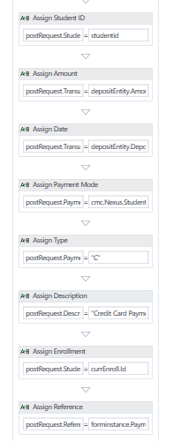

We now want to log the values from the ***postRequest***.

Drag the ***LogObject*** activity onto the designer below the last ***Assign*** activity.

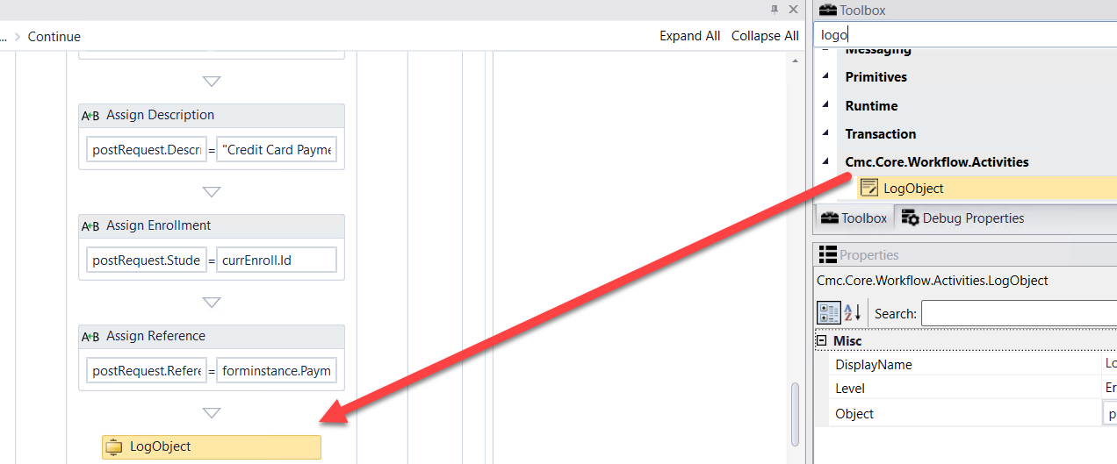

1. Specify the properties in the ***Properties pane*** for the ***LogObject*** activity.

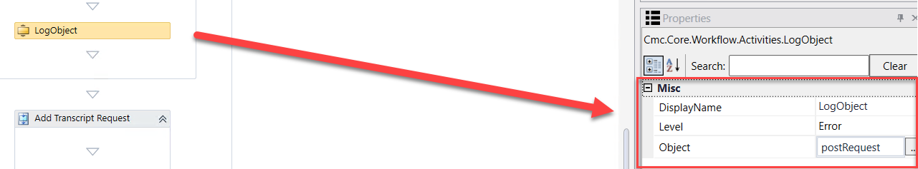

1. Drag an ***Assign*** activity below the ***LogObject*** activity. Update the properties for the activity as follows:

* ***Display Name: Assign Response; postResponse = AcctSvc.PostAccountTransactionPayment(PostRequest)***

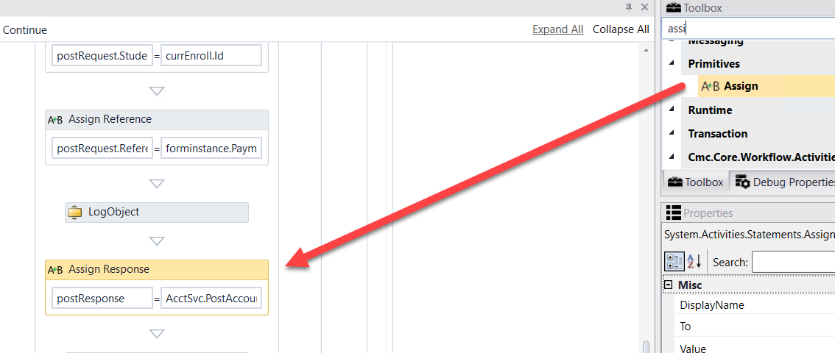

1. We now want to log the values from the ***postResponse***.

Drag the ***LogObject*** activity onto the designer below the ***Assign*** activity.

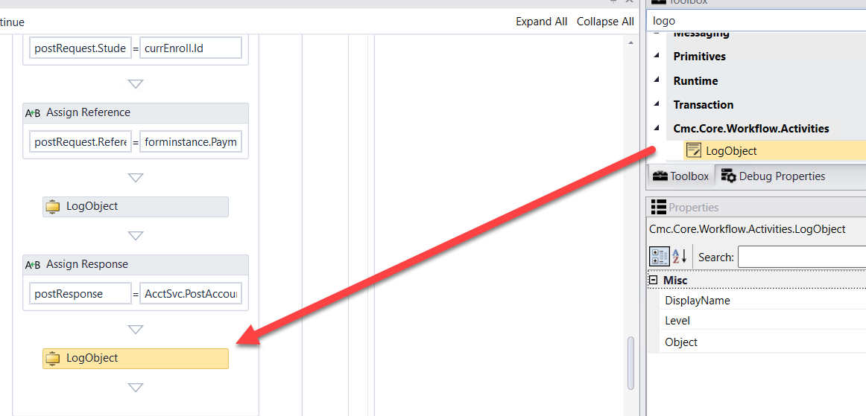

1. Specify the properties in the ***Properties pane*** for the ***LogObject*** activity.

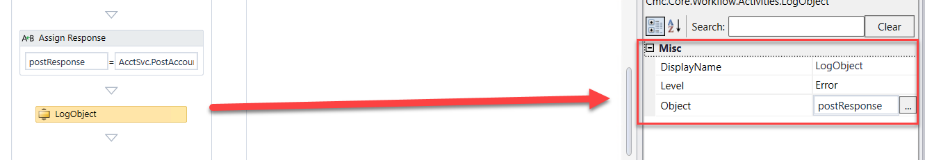

1. Drag two ***Assign*** activities into the ***Add Transcript Request*** sequence. Update the properties for the activities as follows:

* ***Display Name: Assign Student ID; transcriptRequestEntity.StudentId = studentid***
* ***Display Name: Assign Request Date; transcriptRequestEntity.RequestDate = datetime.Now***

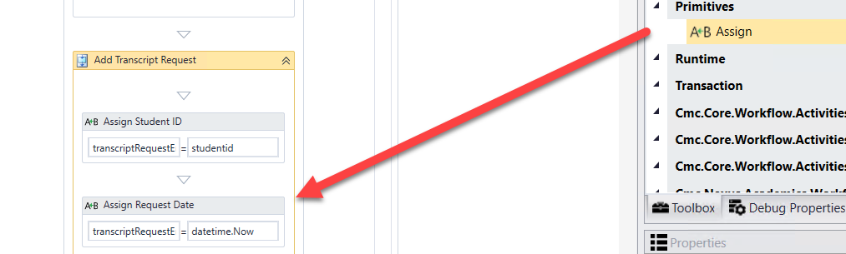

1. Drag a ***SaveEntity*** below the last ***Assign*** activity.

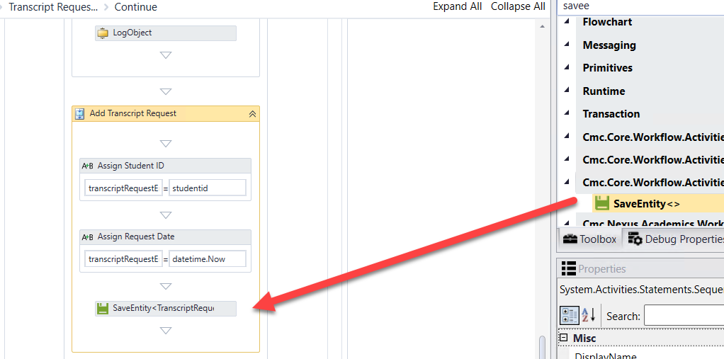

1. When the box pops up, ***Browse for Types*.**



1. Navigate to: Cmc.Nexus.Crm.Contracts>Cmc.Nexus.Crm.Entities>TranscriptRequestEntity and click OK.

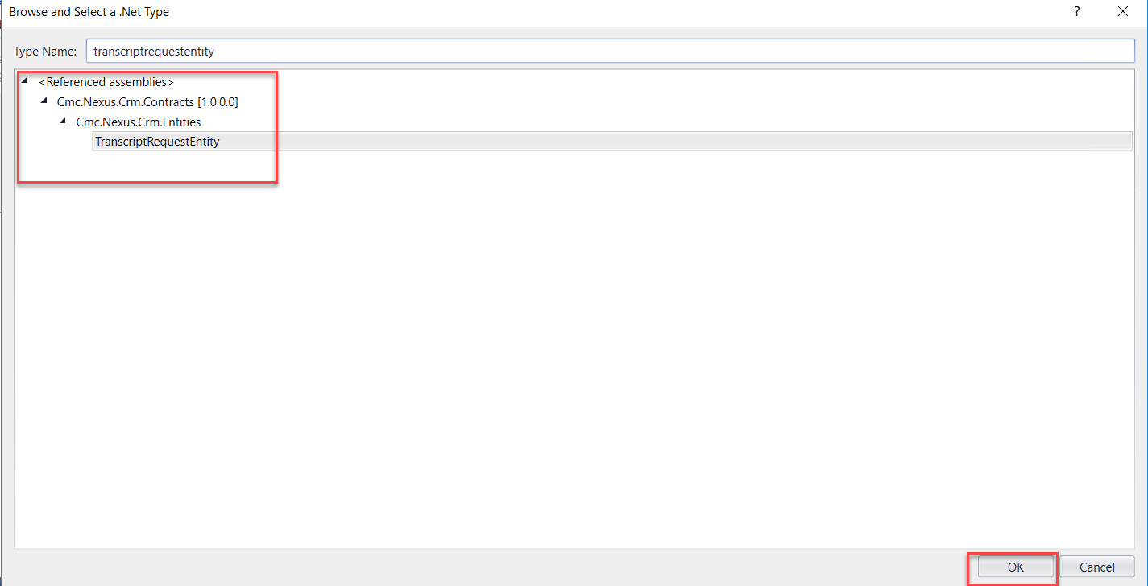

1. Specify the properties in the ***Properties pane*** for the ***SaveEntity*** activity.

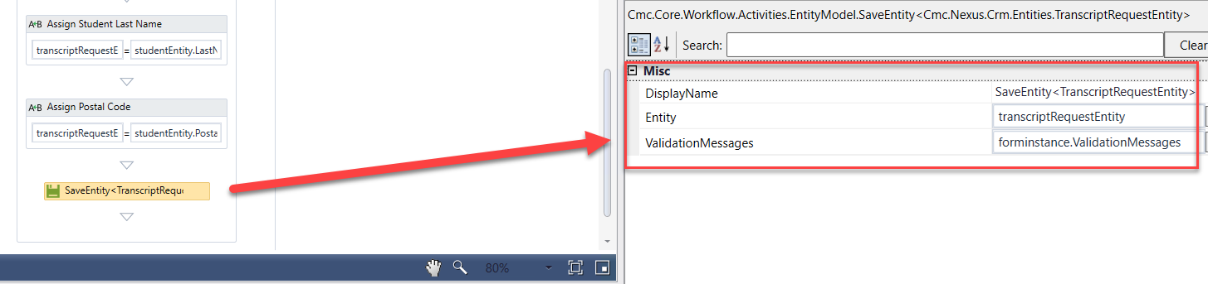

1. Confirm there are no Errors in the Error pane.

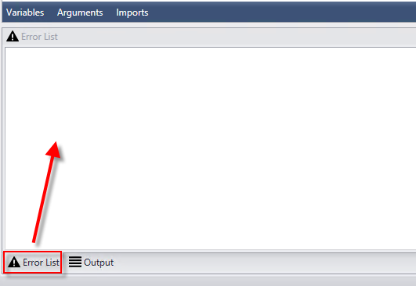

1. ***Save*** your Workflow to a local directory.

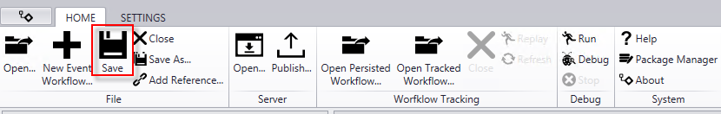

1. ***Publish*** your Workflow. Make sure you select ***Enable This Workflow Version?*** and select ***Publish*.** Select ***OK*** to the confirmation.

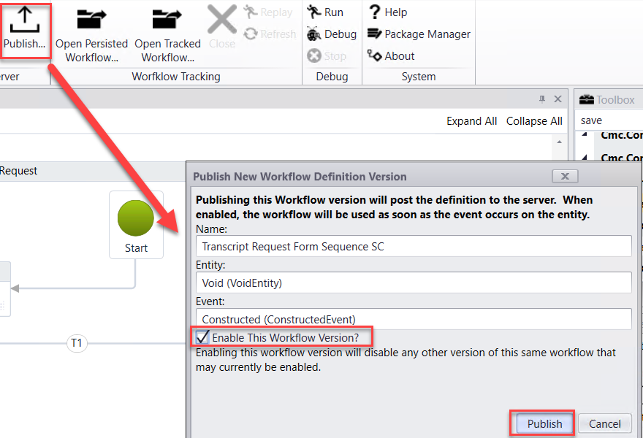

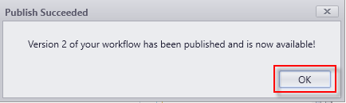

# Lesson 2: Validate the Transcript Request Process

In this lesson, you will validate the Transcript Request Process by logging in as a student and completing the Transcript Request Form Sequence. You will then validate the student record in the CampusNexus Web Client to ensure a Transcript Request was received and a Transcript Charge and Transcript Payment was posted to the Ledger Card.

## Exercise: Validate the Transcript Request Process

1. Navigate to ***Google Chrom*e** and launch ***Student*** from the ***Bookmarks Bar***.



1. ***Sign in*** using the following credentials:

***administrator***

***testing***

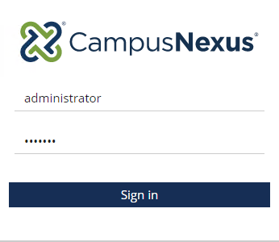

1. Select ***Students*.**



1. Search for student ***George Becker*** and click on the student link to open the student record.

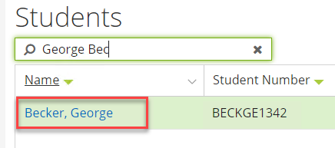

1. View the student's ***Transcript Requests*** Information: ***Contact Manager>Transcript Requests***

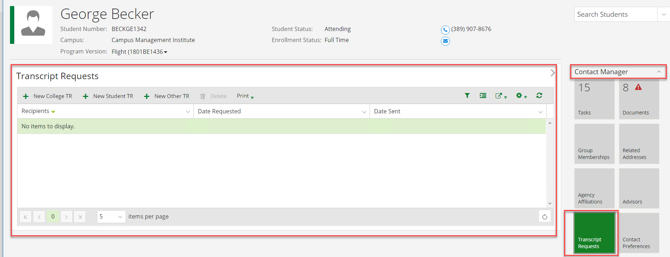

1. View the student's ***Ledger Card*** Information: ***Student Accounts>Ledger Card***

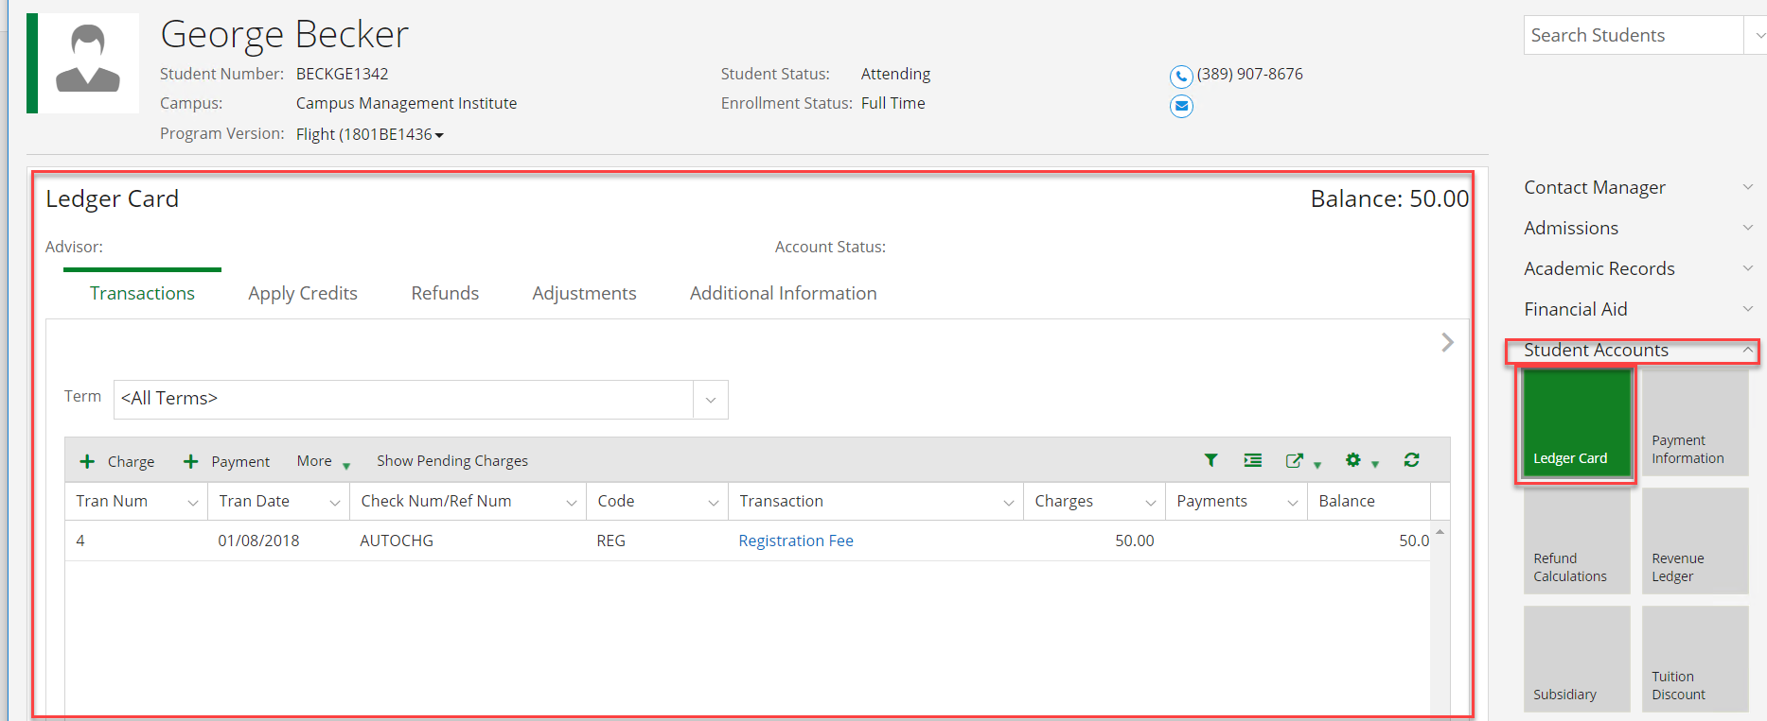

1. Open ***Google Chrome*** and launch ***Renderer*** from the ***Bookmarks Bar***.



1. Find your ***Transcript Request Form Sequence*** in the list and click the ***arrow*** to navigate to the sequence.

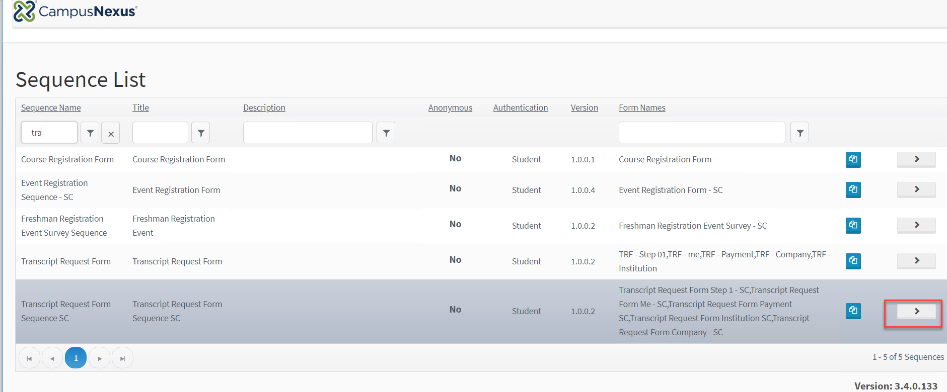

1. Log in as the student:

***Username: george.becker***

***Password: nexus123***

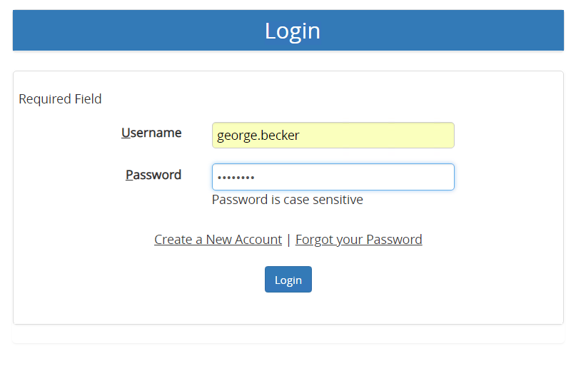

1. Complete the form for the student.

***Note: Use credit card # 4111111111111111 and expiration date 09/21 for the payment.***

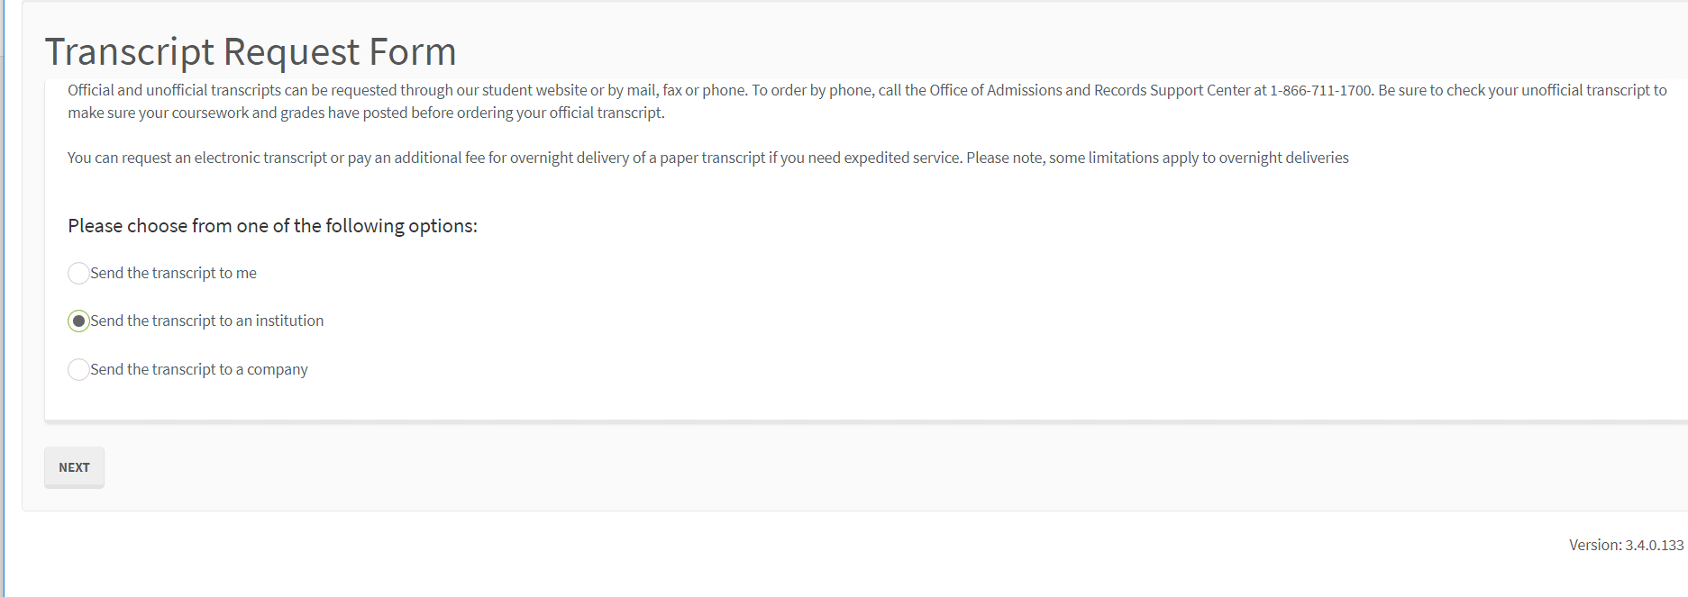

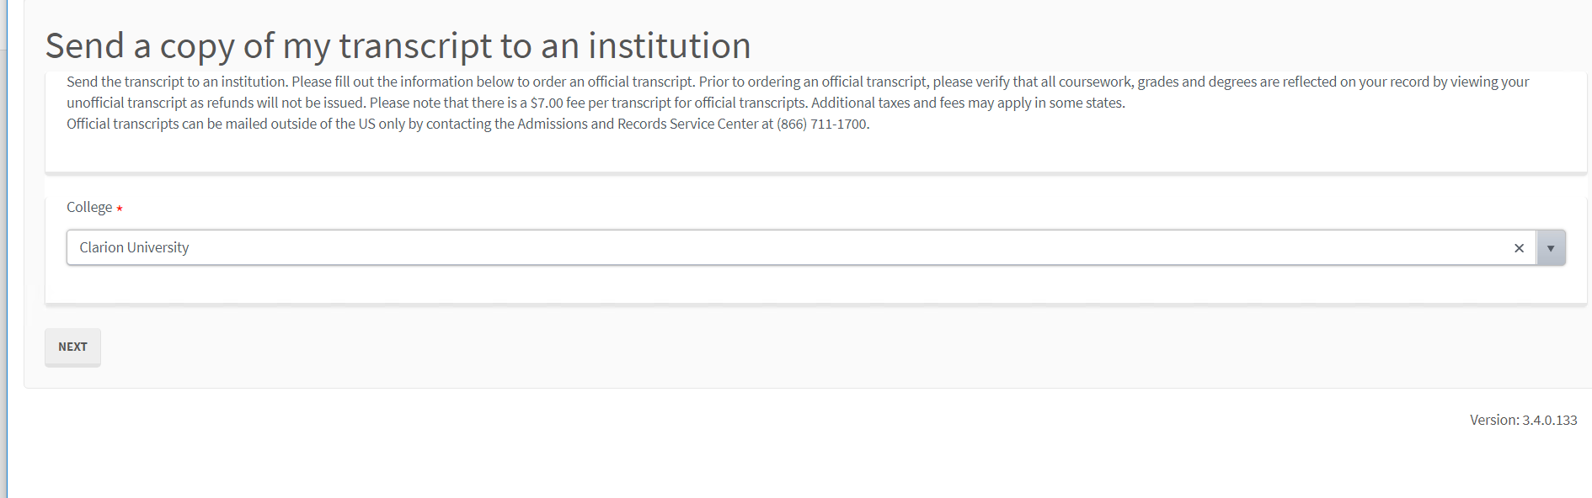

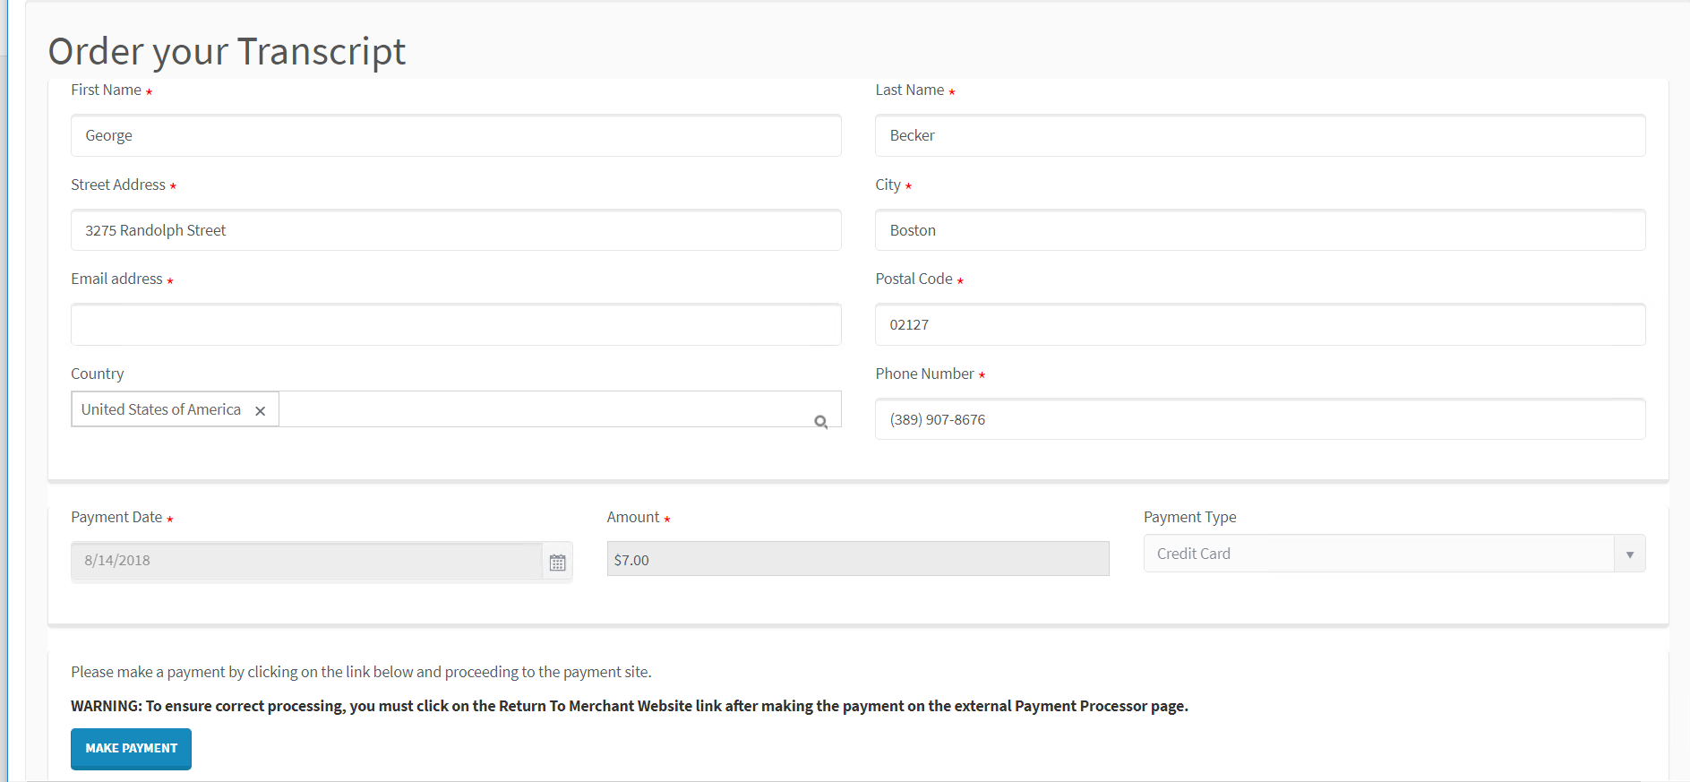

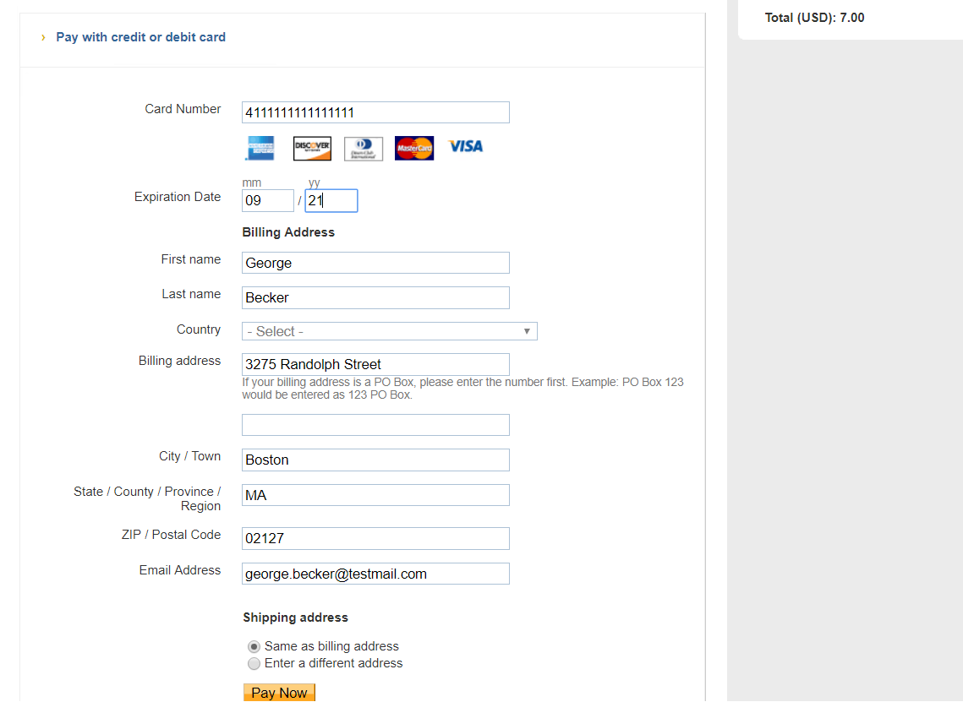

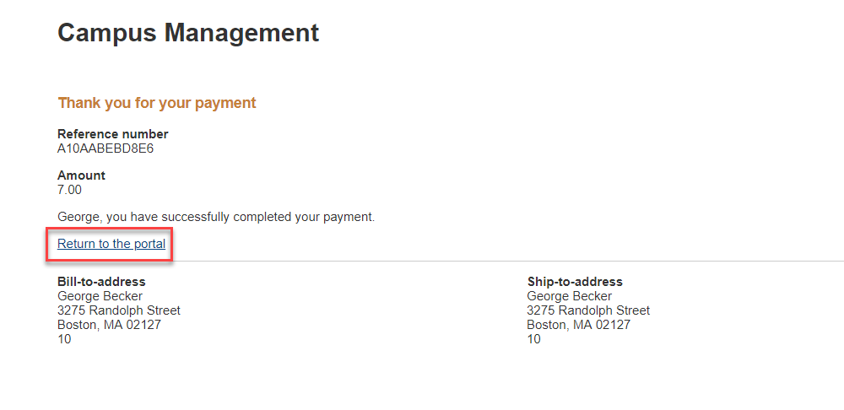

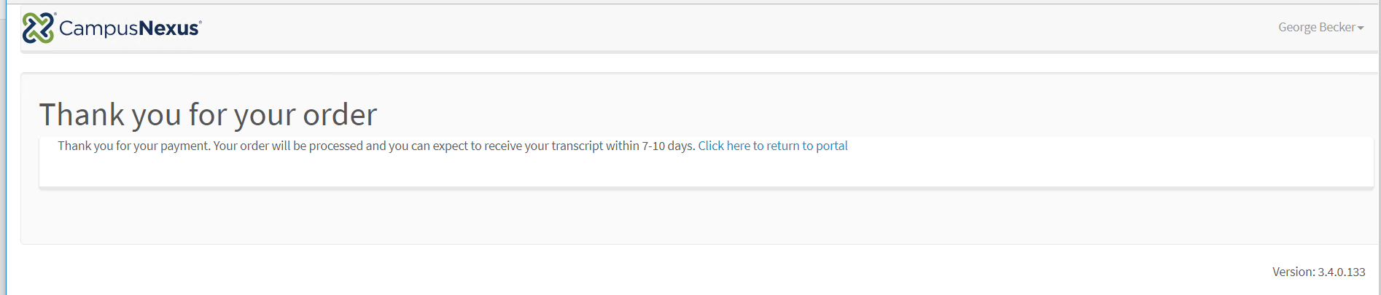

1. Navigate back to ***CampusNexus Student*** and validate that transcript request was added for the student.

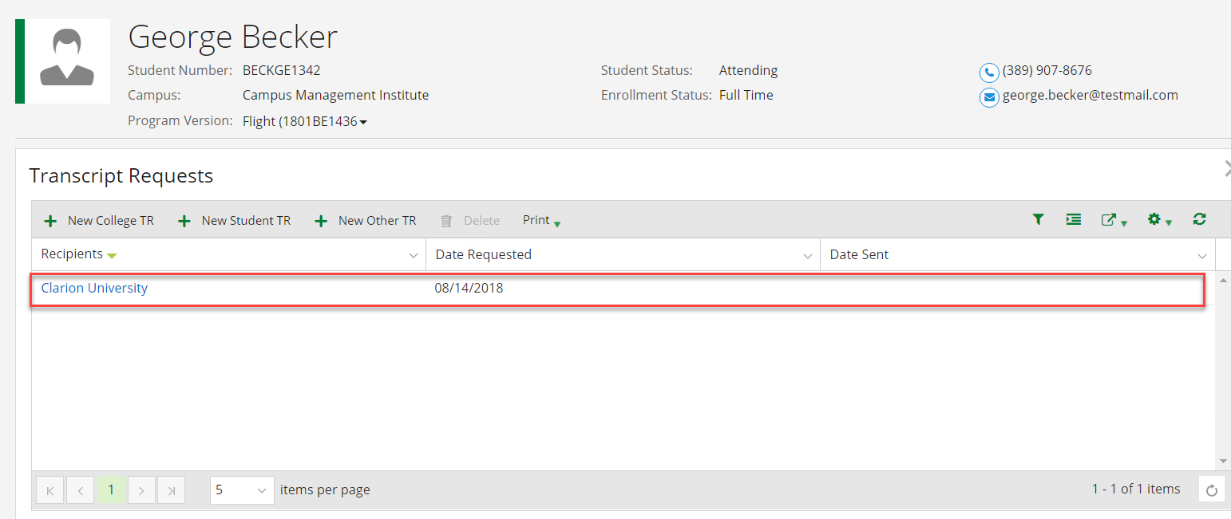

1. Validate that the student's transcript charge and payment posted to the ledger.

